# Knee Detection for Lateral Knee Images: User Manual

By Lu Yik Ho

# Introduction

This knee detection program aims to crop the original lateral knee X-ray image to the region of interest, which contains only the joint and all bones, particularly the patella.

The program mainly features the YOLO Version 11 Segmentation Nano Model by Ultralytics, applying the model to segment the region of interest from the image, and LabelMe, a free-to-use Python software that has an easy image labelling process.

The Jupyter Notebook program also contains image preparation, data compiler, model training, inference tools and image post-processing to aid the cropping process.

This user manual aims to be a comprehensive guide of the program, explaining the details of the functions used in the program, while demonstrating the usage by providing sample input parameter values and expected outputs.

# 

# 

# Table of Contents:

**Introduction 1**

**Table of Contents: 2**

**Step 1: Program Requirements 2**

1.1 Required Python Files 3

1.2 Suggested Directories 4

1.3 Required Python Modules 5

1.4 Installing LabelMe 6

**Step 2: Preparing Images for LabelMe 6**

2.1 Retrieving Images from DICOM Files 6

2.2 Flipping Images 7

2.3 Cropping Images 9

2.4 Normalising Images 11

**Step 3: Creating Bounding Boxes with LabelMe 13**

3.1 Initialising LabelMe 13

3.2 Opening Image Directory 14

3.3 Drawing Rectangle Bounding Box 15

3.4 Saving Bounding Box 17

**Step 4: Creating YOLO Required Dataset 17**

4.1 Splitting Training and Inference Images 18

4.2 Converting LabelMe JSON file to YOLO TXT file 18

4.3 Creating YOLO Dataset 20

4.4 Creating YOLO YAML file 21

**Step 5: Fine-tuning YOLO Model 22**

5.1 Fine-Tuning New Model 22

5.2 Re-training Trained Model 25

5.3 Interpreting Training Results 25

**Step 6: Inference with Tuned Model 30**

6.1 Dataset Preparation 30

6.2 Running Inference 31

**Step 7: Cropping Images with Tuned Model 33**

7.1 Cropping Rectangular Image 33

7.2 Cropping Square Image 34

7.3 Post-processing 37

**Conclusion 39**

**Acknowledgement: 39**

# Step 1: Program Requirements

This program requires preinstalled modules. This step provides a guide on the required modules.

## 1.1 Required Python Files

The KneeDetectionLateral_v1.1_main Jupyter Notebook imports all functions from the KneeDetectionLateral_ImageProcessing.py and KneeDetectionLateral_TrainYoloModel.py files.

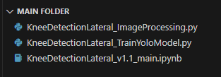

*Figure 1.1.1 Required Python Files placed under Main Folder*

Please ensure these three files are located in the main folder.

This program was run and tested in Visual Studio Code, within a virtual environment in Python 3.13.5.

A GPU is required to operate PyTorch. For this demonstration, CUDA 12.6 was used.

## 

## 1.2 Suggested Directories

The program can support most types of directory or folder structures.

However, it is recommended to follow this directory structure to help keep files separate.

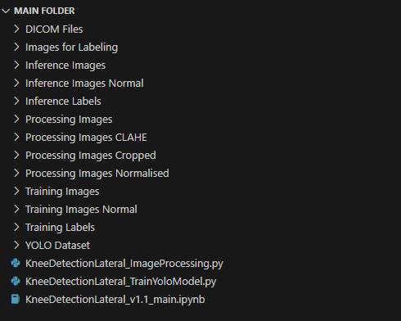

*Figure 1.2.1 Suggested Main Folder Structure*

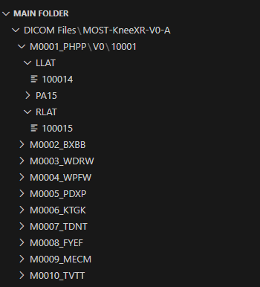

*Figure 1.2.2 Suggested DICOM Files Folder Structure*

The user manual and the following demonstrations will follow this folder structure.

## 

## 1.3 Required Python Modules

These are the required modules used:

Under Python Standard Library:

* os: <https://docs.python.org/3/library/os.html>
* glob: <https://docs.python.org/3/library/glob.html>
* shutil: <https://docs.python.org/3/library/shutil.html>

Installation required:

* torch: <https://pytorch.org/>
* torchvision: <https://pypi.org/project/torchvision/os>
* matplotlib: <https://matplotlib.org/>
* cv2: <https://pypi.org/project/opencv-python/>
* PIL: <https://pillow.readthedocs.io/en/stable/>
* numpy: <https://numpy.org/>
* ultralytics: <https://docs.ultralytics.com/quickstart/>

Run the “Step 1.3” section once when starting the Jupyter kernel to confirm all modules are installed and can be successfully imported.

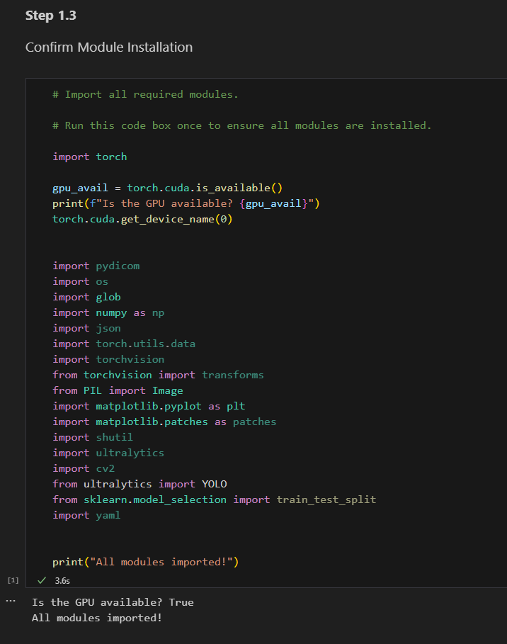

*Figure 1.3.1 “Step 1.3” Section and Expected Output*

## 1.4 Installing LabelMe

The program specifically requires bounding boxes generated by LabelMe.

It is recommended to use Anaconda Package Manager to install LabelMe due to the large number of dependencies.

Anaconda Download: <https://www.anaconda.com/download>

LabelMe Install Instructions: <https://labelme.io/docs/install-labelme-pip>

# Step 2: Preparing Images for LabelMe

These steps consist of processing the images retrieved from DICOM files. These steps aid in labelling bounding boxes with LabelMe and in training the YOLO model.

The training images and inference images should not be split yet to process all images at once.

## 2.1 Retrieving Images from DICOM Files

This step retrieves images in PNG format from DICOM files.

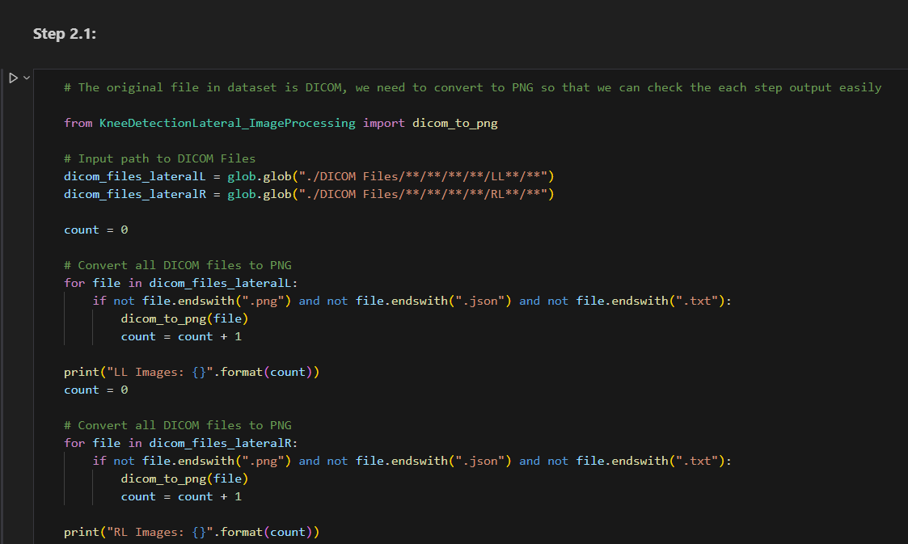

*Figure 2.1.1 “Step 2.1” Section*

### Input: DICOM Files

Edit the strings in this code to change the directories to DICOM files.

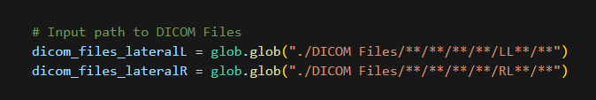

*Figure 2.1.2 “Step 2.1” Sample DICOM Files Input*

### Output: PNG File & DICOM File Contents

Each image should be stored in the same folder as its respective DICOM file.

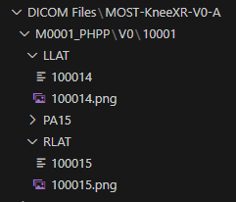 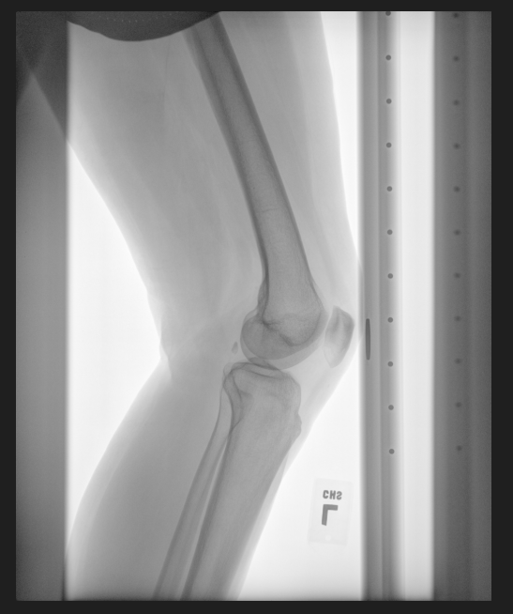

*Figure 2.1.3 “Step 2.1” Sample Output Structure Figure 2.1.4 “Step 2.1” Sample PNG Image*

The information within the DICOM files will also be printed.

## 2.2 Flipping Images

This step flips images horizontally. Specifically, this step flips the right knee images to align with the left knee. Skip this step if training a model for detecting both left and right knees.

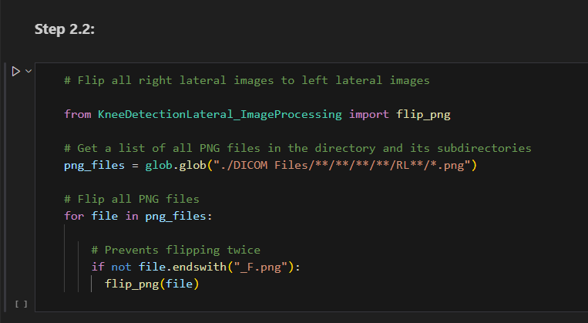

*Figure 2.2.1 “Step 2.2” Section*

### Input: Original PNG File

Edit the strings in this code to change the directories to the target PNG files.

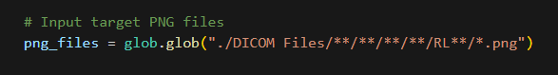

*Figure 2.2.2 “Step 2.1” Sample Input Parameter*

### Output: Flipped PNG File

Each flipped image should be stored in the same folder as its original PNG file, with “_F.png” added as a suffix.

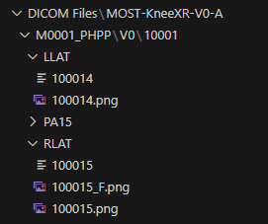

*Figure 2.2.3 “Step 2.2” Sample Output Structure*

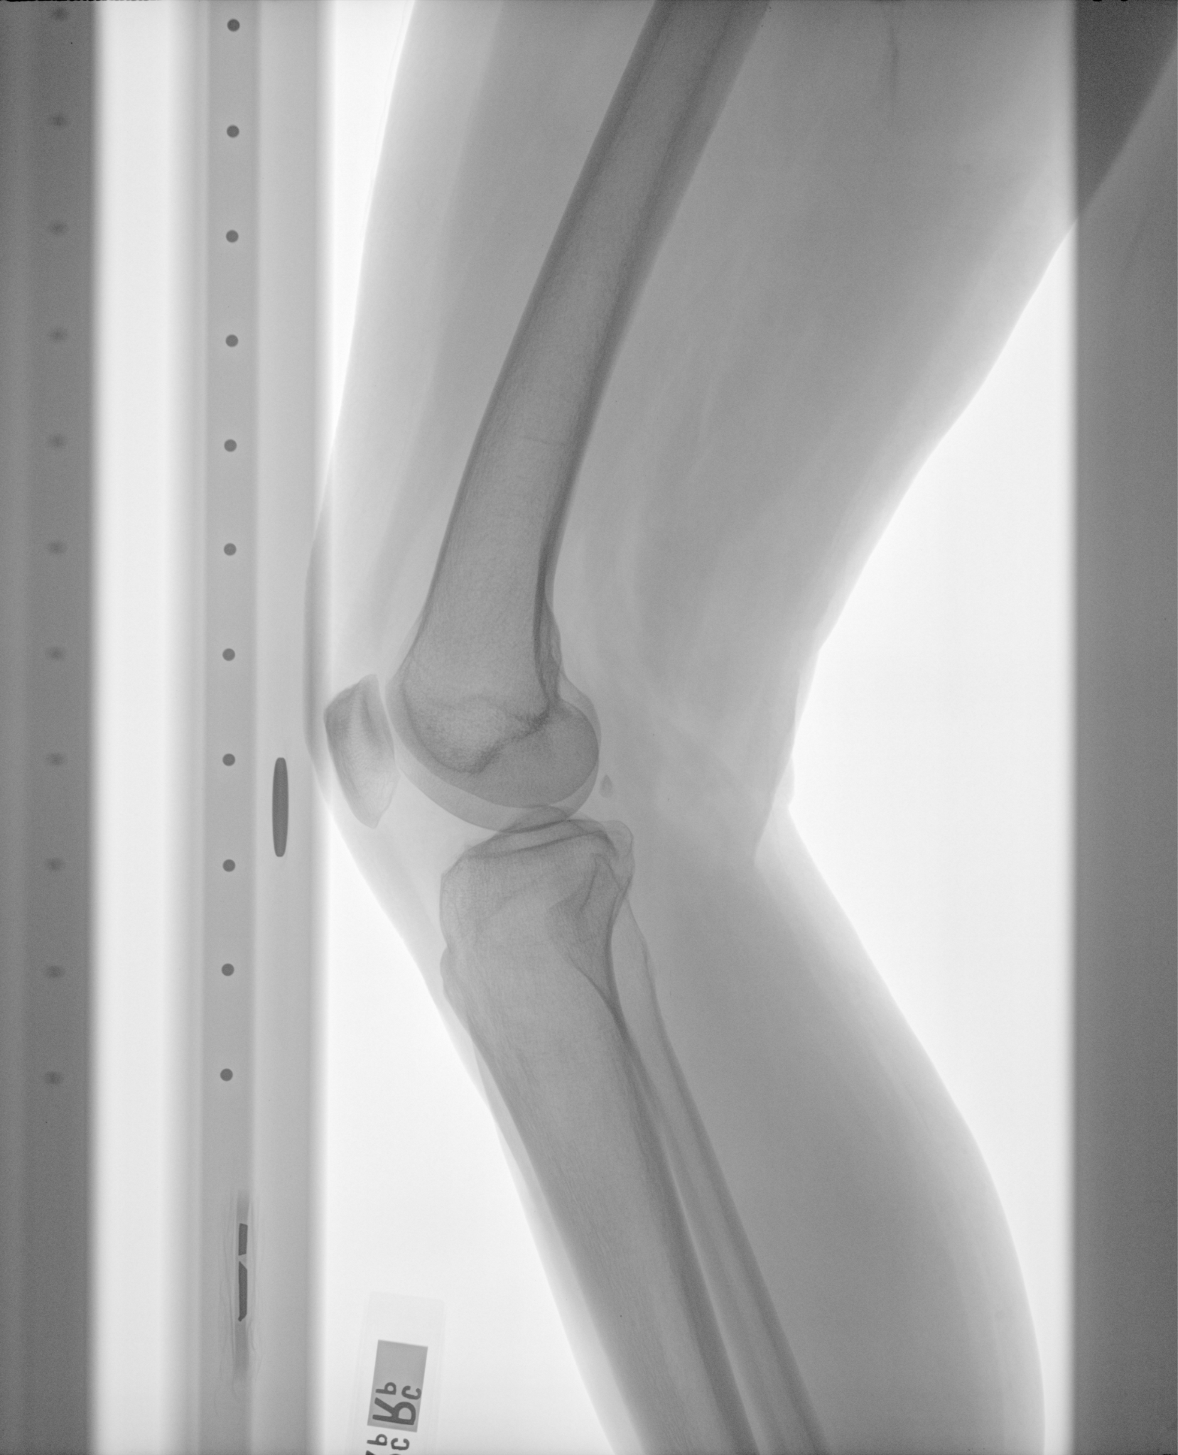 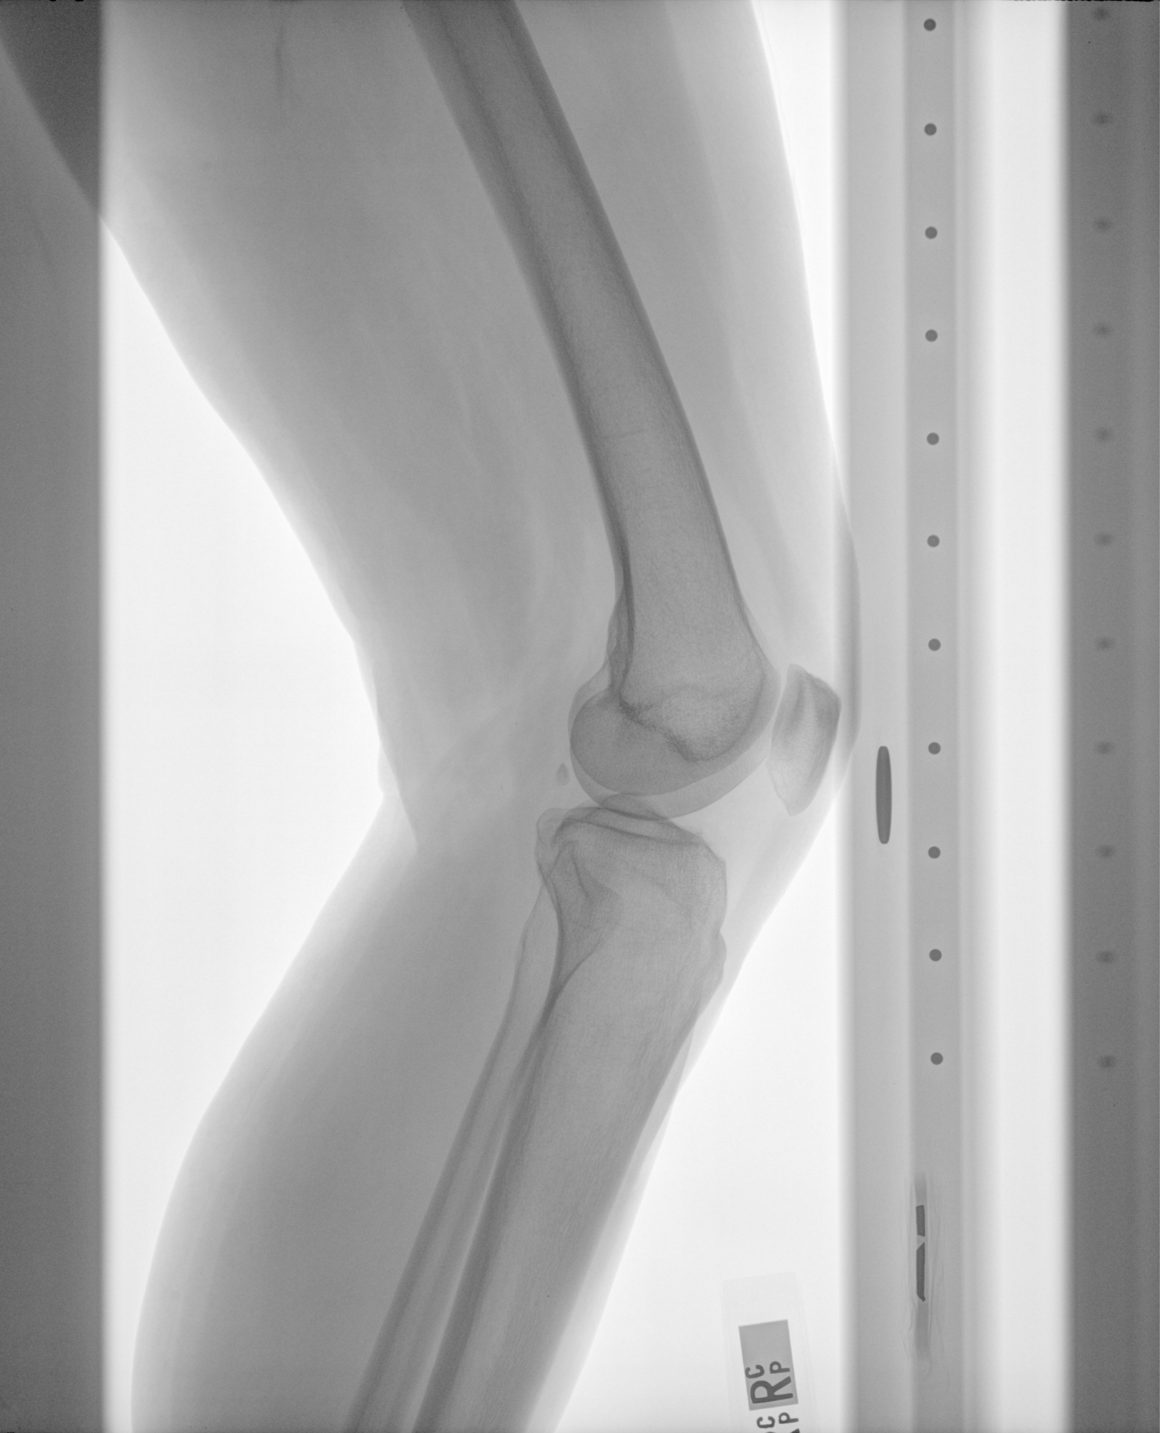

*Figure 2.2.4 “Step 2.2” Sample Input PNG Image Figure 2.2.5 “Step 2.2” Sample Output PNG Image*

## 

## 2.3 Cropping Images

This step crops away a portion of the image.

This solves the problem of two joints appearing in a single image.

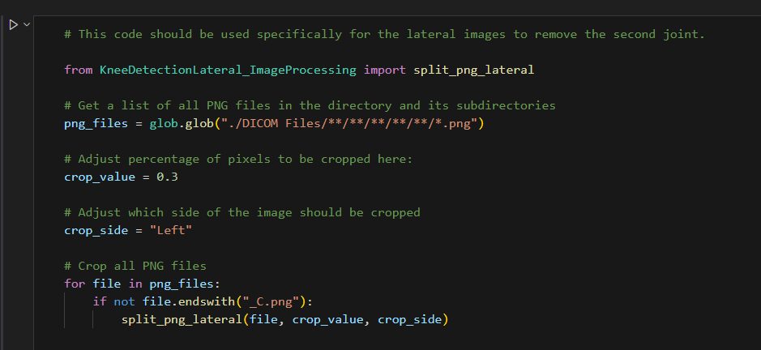

*Figure 2.3.1 “Step 2.3” Section*

### Input: Original PNG Files, Cropping Parameters

png_files: The target PNG files. Update the string to retrieve the correct target PNG files.

crop_value: The percentage of the image to be cropped. The value should be between 0 and 1.

crop_side: Input “Left” or “Right” to select which side of the image should be cropped.

Suggestion: If using left knee images and flipped right knee images, running once with preset parameters should be enough. If not using flipped images, split_png_lateral() should be run twice with flipped crop_side values for left knee images and right knee images separately.

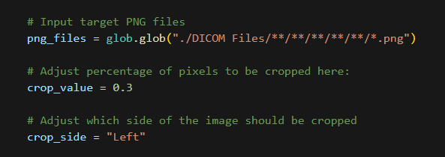

*Figure 2.3.2 “Step 2.3” Sample Input Parameters*

### 

### Output: Cropped PNG Files

Each cropped image should be stored in the same folder as its original PNG file, with “_C.png” added as a suffix.

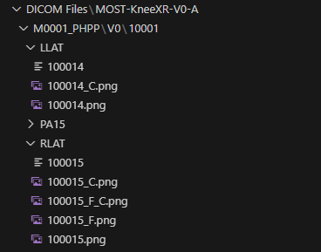

*Figure 2.3.3 “Step 2.3” Sample Output Structure*

Output images using different parameter values:

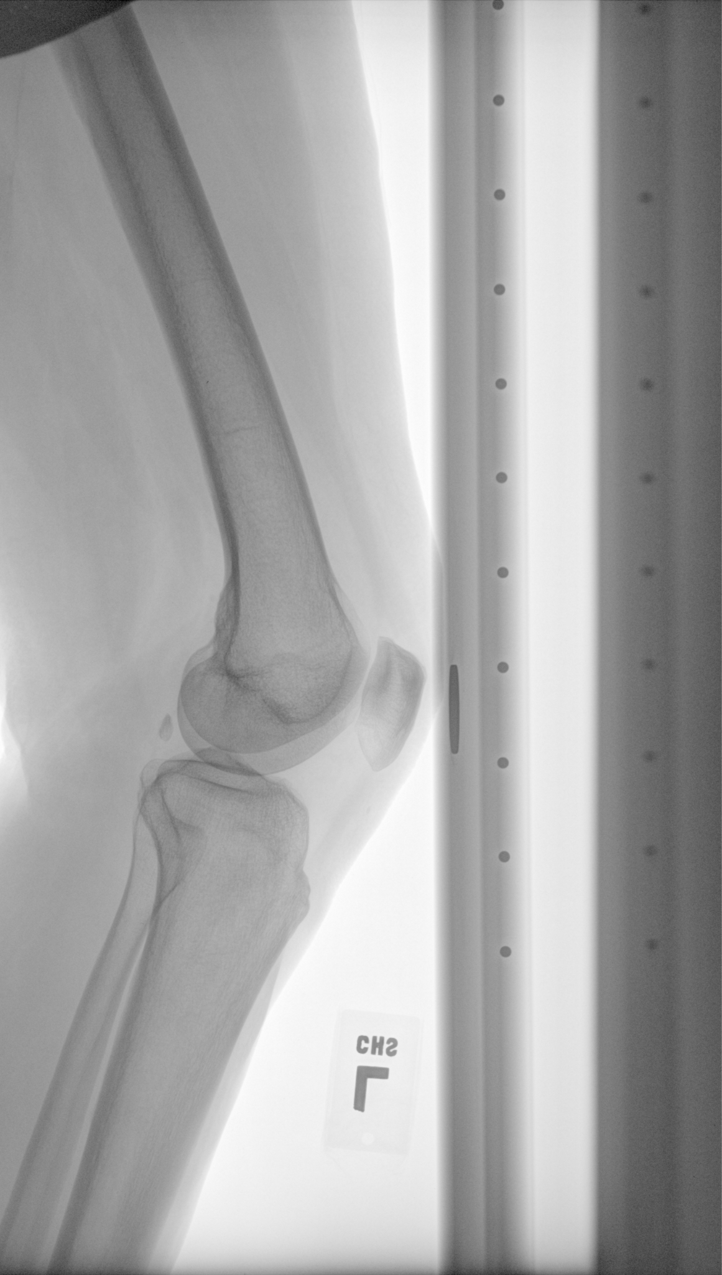 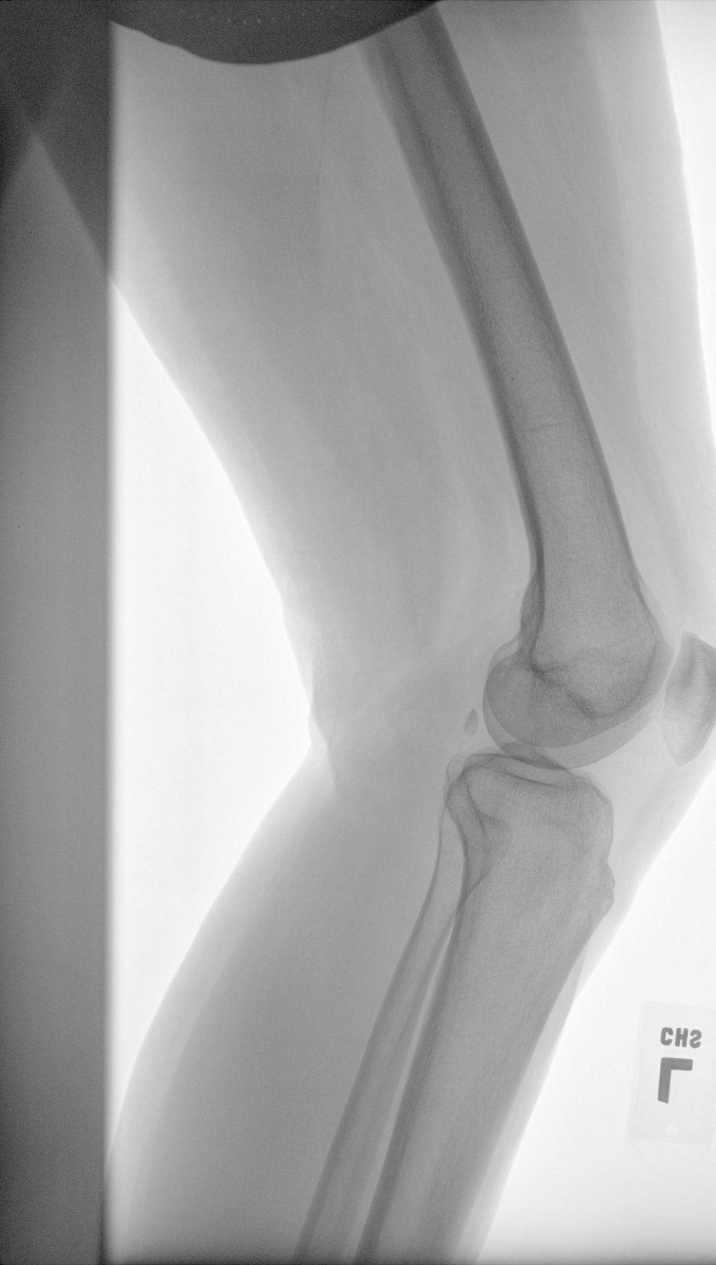

*Figure 2.3.4 “Step 2.3” Sample “0.3, Left” Output Figure 2.3.5 “Step 2.3” Sample “0.3, Right” Output*

Input image for comparison:

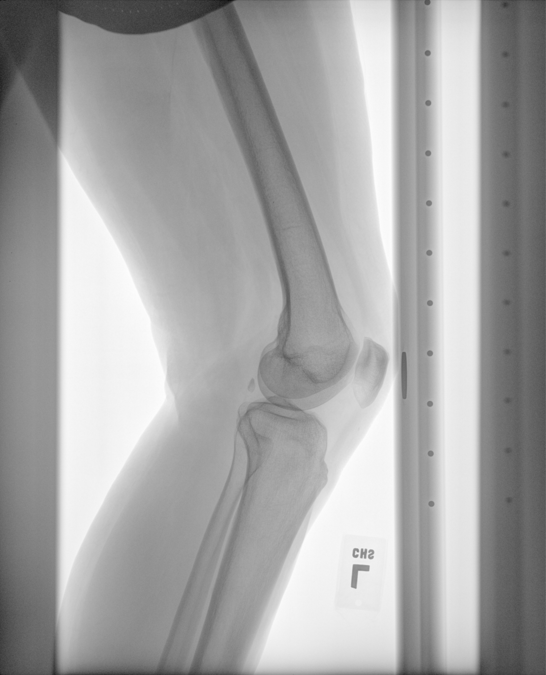

*Figure 2.3.6 “Step 2.3” Sample Input PNG Image*

## 2.4 Normalising Images

This step normalised images to improve contrast, aiding in defining bounding boxes and model training.

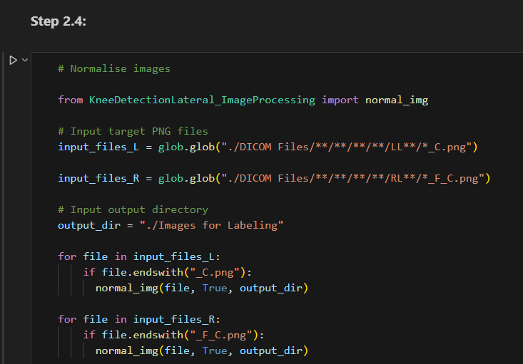

*Figure 2.4.1 “Step 2.4” Section*

### Input: (Flipped) Cropped PNG Files, Output Directory

input_files: The target PNG files. Update the string to retrieve the correct target PNG files.

output_dir: The target folder to save output files. Update the string to change the target folder.

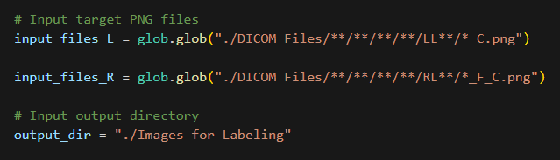

*Figure 2.4.2 “Step 2.4” Sample Input Parameters*

### Output: Normalised PNG Files, Pixel Value Range

The images should be stored in the targeted folder, with “_N.png” added as a suffix.

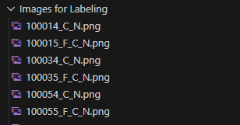

*Figure 2.4.3 “Step 2.4” Sample Output Structure*

Output image comparison:

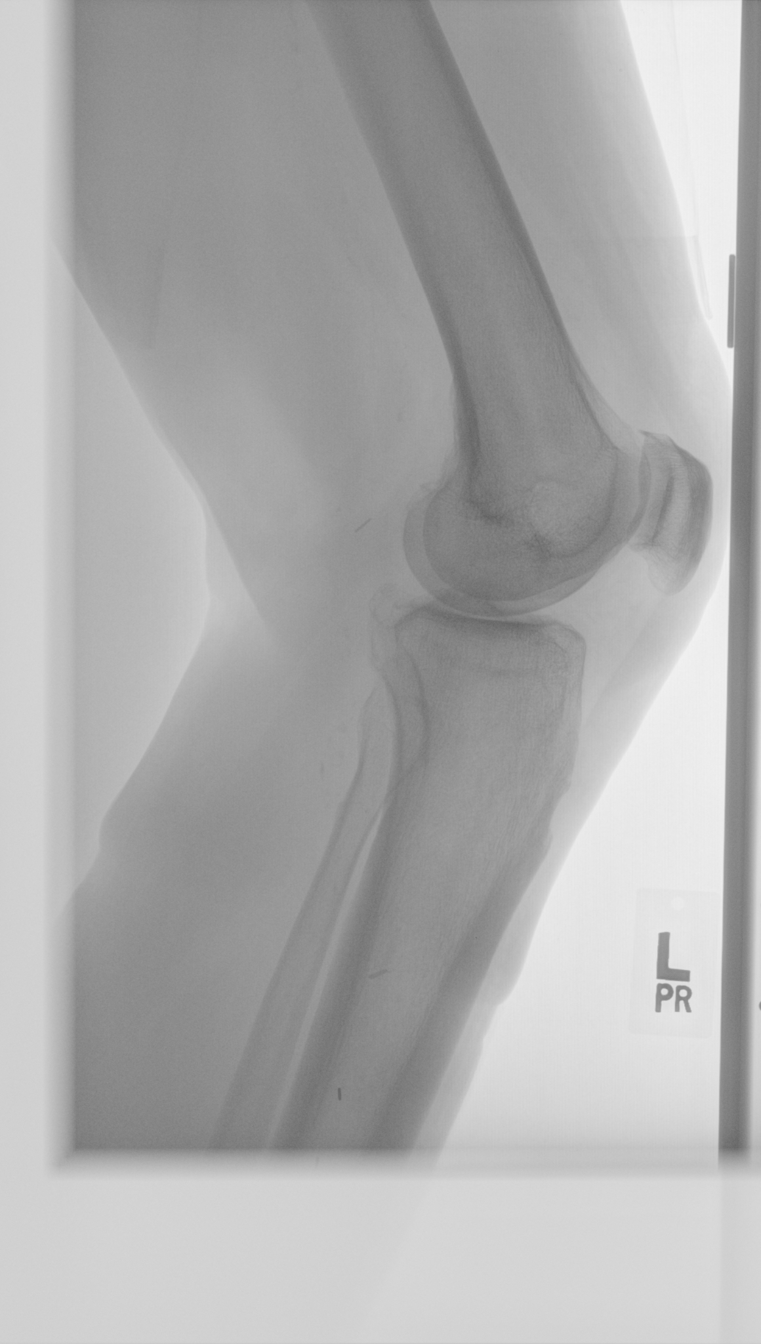 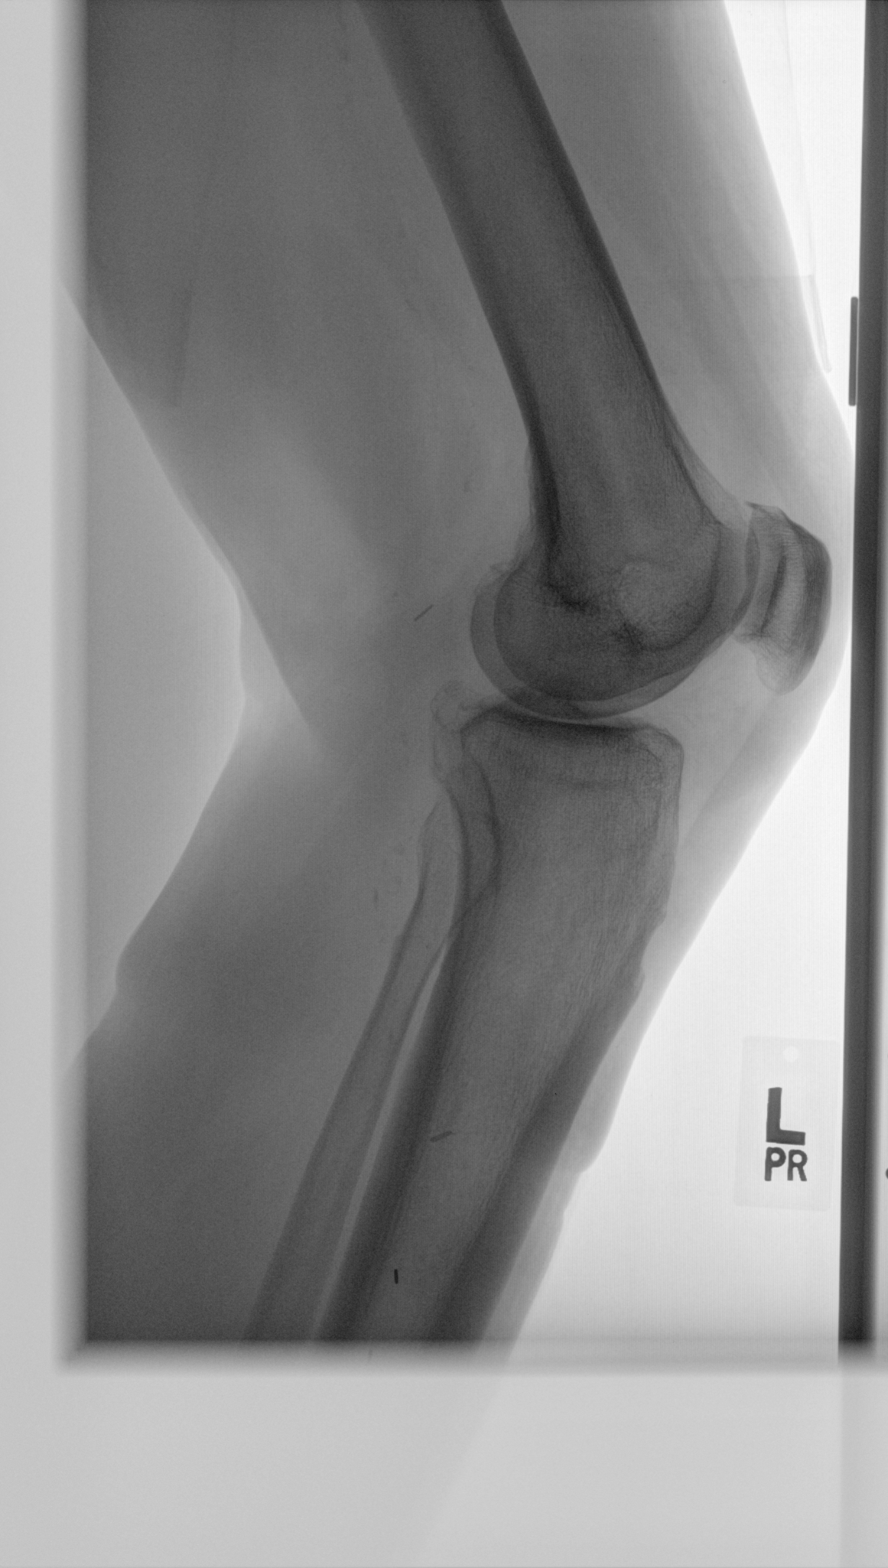

*Figure 2.4.4 “Step 2.4” Sample Input Image Figure 2.4.5 “Step 2.4” Sample Output Image*

The maximum value and the lowest value of pixels are printed. The smaller the difference, the higher the effect normalisation has.

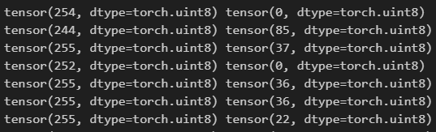

*Figure 2.4.6 “Step 2.4” Sample Printed Output (Maximum Value, Minimum Value)*

### 

# 

# Step 3: Creating Bounding Boxes with LabelMe

LabelMe is the main program used to create the bounding box of the region of interest. These steps provide a guide to the specific method to use LabelMe for this program.

## 3.1 Initialising LabelMe

1. Start “Anaconda Prompt”
2. Type and execute: “labelme”

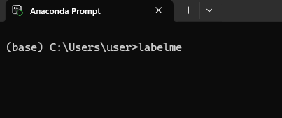

*Figure 3.1.1 Opening LabelMe with Anaconda Prompt*

If LabelMe successfully initialises, the LabelMe GUI will open:

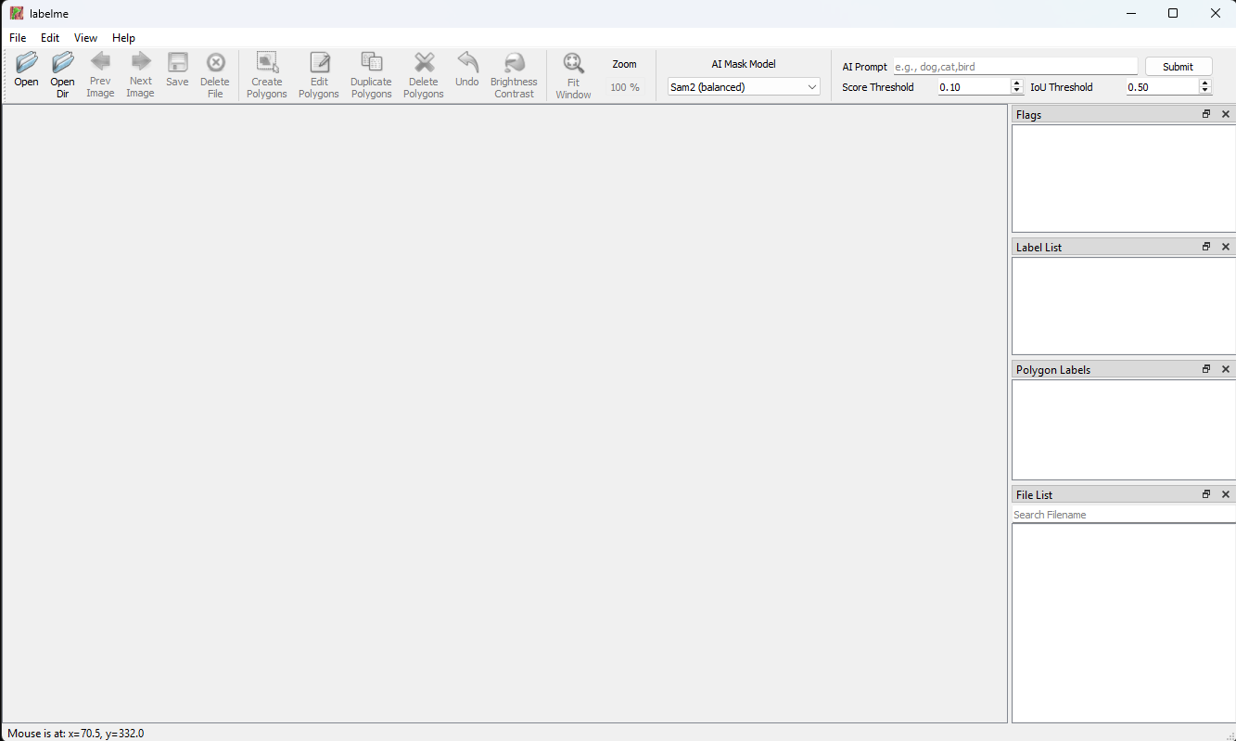

*Figure 3.1.2 LabelMe GUI*

Anaconda Prompt should report feedback from opening LabelMe:



*Figure 3.1.3 Anaconda Prompt Feedback*

## 3.2 Opening Image Directory

1. Select “Open Dir” or input [Ctrl+U]

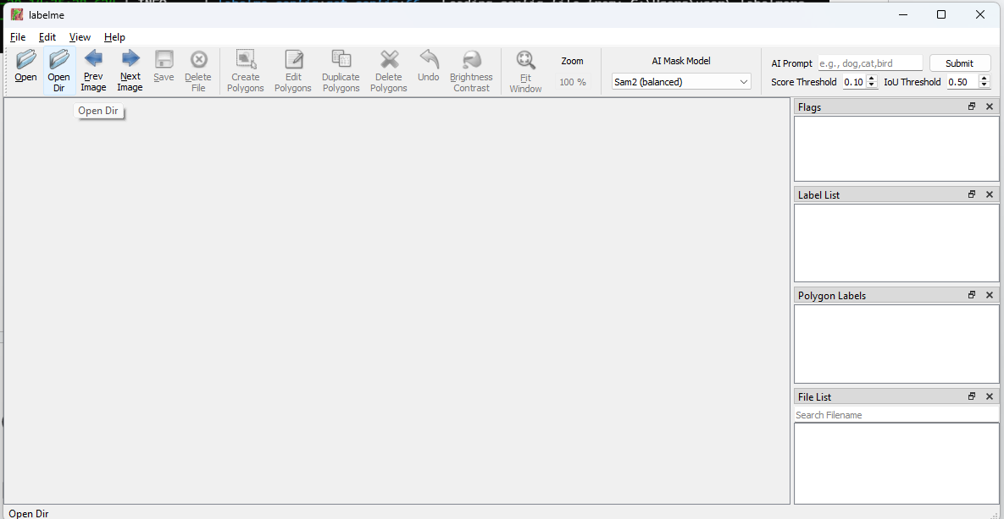

*Figure 3.2.1 LabelMe “Open Dir” Button*

1. Select the folder containing your images

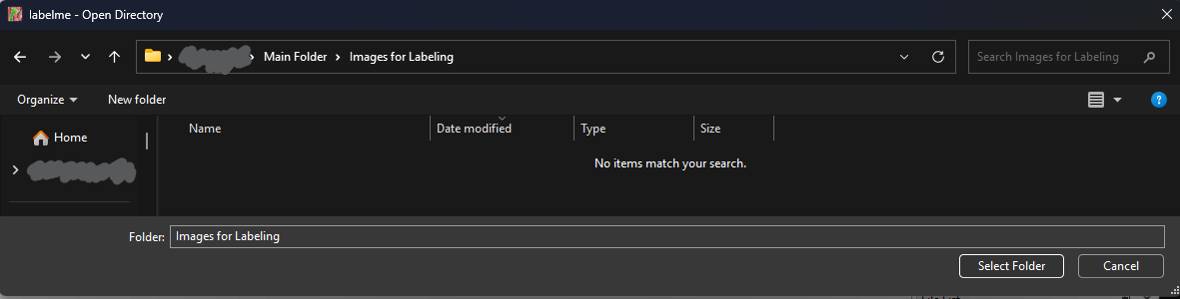

*Figure 3.2.2 LabelMe Open Directory*

If opening the directory is successful, this should be the resulting screen shown in LabelMe.

The image files and their JSON files can be accessed through the “File List” Box at the bottom right.

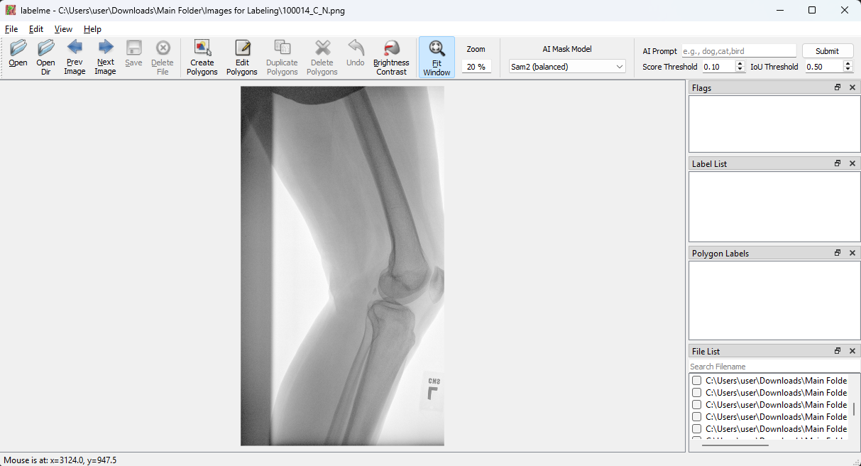

*Figure 3.2.3 LabelMe GUI After Opening Directory*

## 3.3 Drawing Rectangle Bounding Box

The notebook requires bounding box information created by the “Create Rectangle” tool.

Errors may occur if other tools are used instead.

Use “Create Rectangle” Tool: [Right click -> Create Rectangle] or [Ctrl+R]

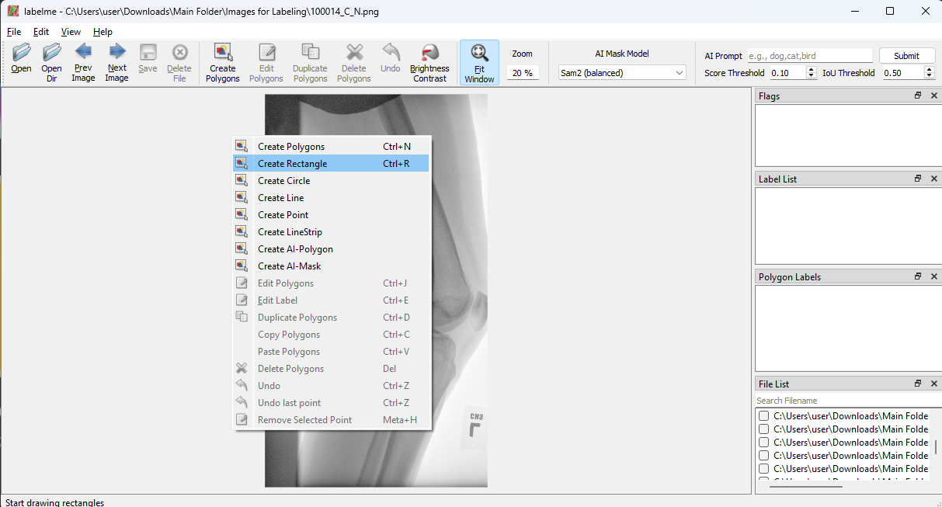

*Figure 3.3.1 “Create Rectangle” in Right-Click Menu in LabelMe*

There should be a horizontal and vertical line at the mouse pointer after selecting this option.

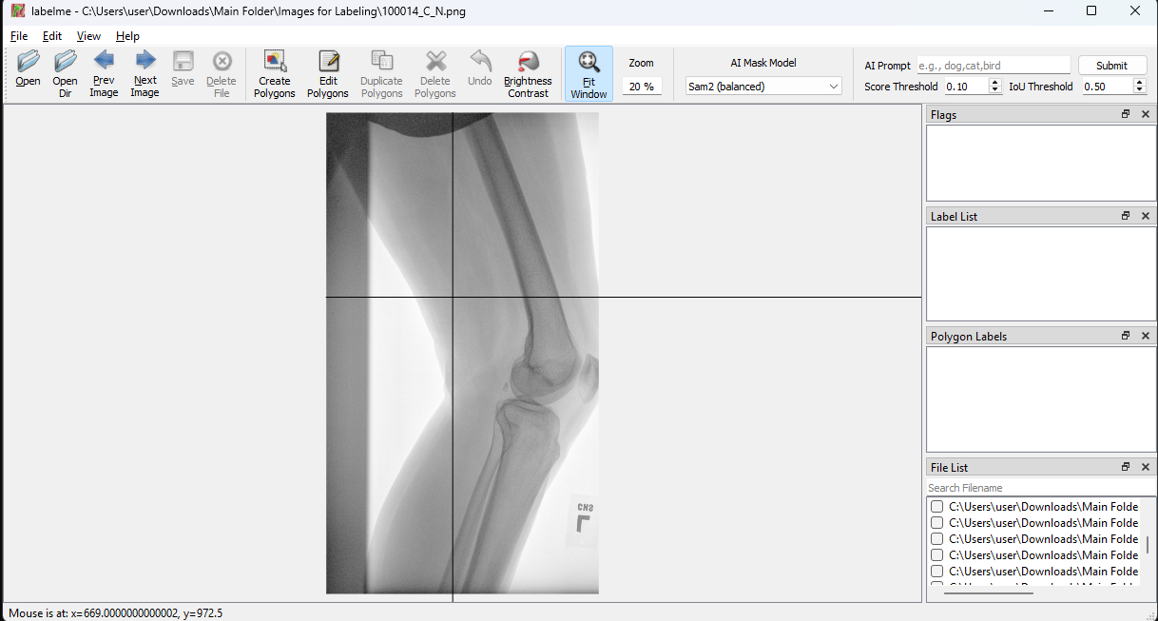

*Figure 3.3.2 Horizontal and Vertical Lines at Mouse Pointer in LabelMe*

Drawing Rectangle:

1. Click the top left corner of the bounding box.
2. Click the bottom right corner of the bounding box.
3. Name the object label (any name works), leave Group ID empty.
4. Select “OK” or input [Enter] to confirm bounding box information.

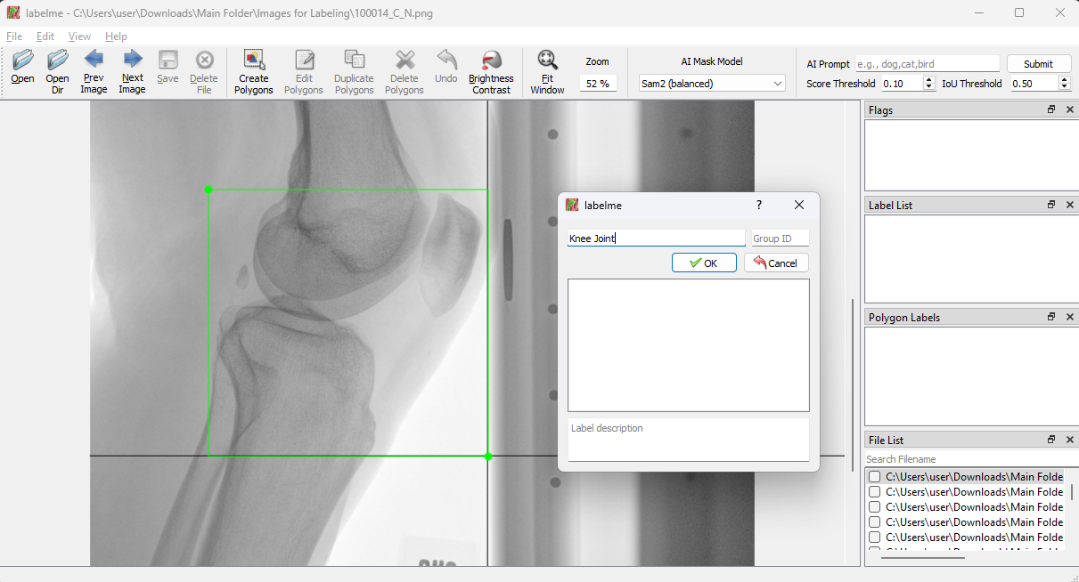

*Figure 3.3.3 Creating a Rectangle Bounding Box in LabelMe*

Editing Rectangle:

1. Select “Edit Polygons” on the Toolbar or input [Ctrl+J]
2. To move a corner, click and drag the corner point.
3. To move the rectangle, click and drag the rectangle.

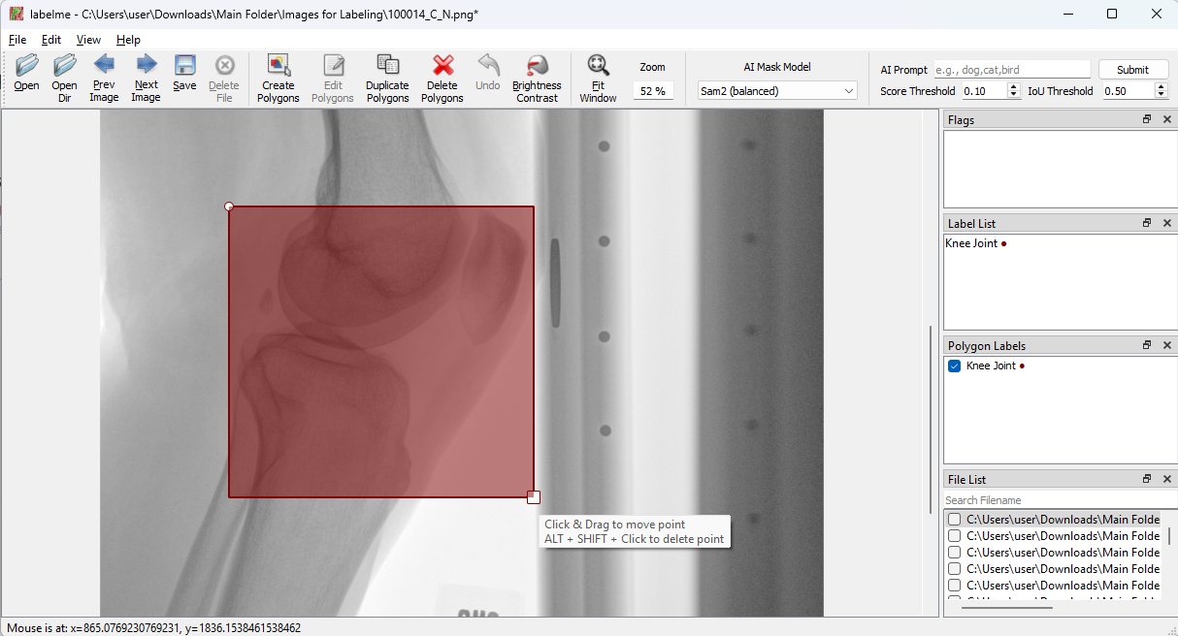

*Figure 3.3.4 Editing a Rectangle Bounding Box in LabelMe*

## 3.4 Saving Bounding Box

1. Select “Save” on the Toolbar or input [Ctrl+S].
2. Save the file **without** changing the file name or file type.

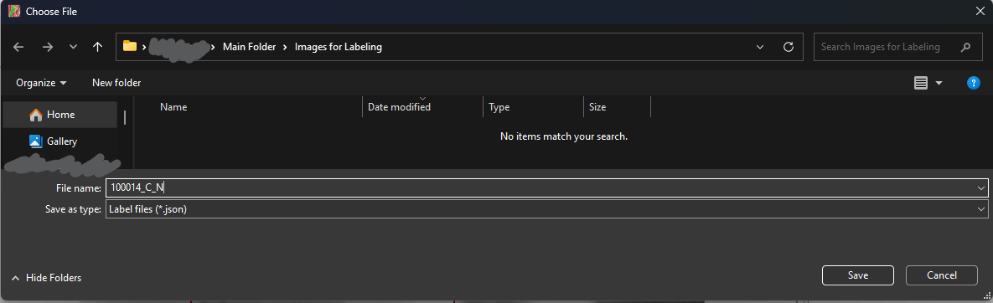

*Figure 3.4.1 Saving JSON File in LabelMe*

Images with a saved JSON file will have a blue checkmark. Further saving will save the updated information into the same JSON file.

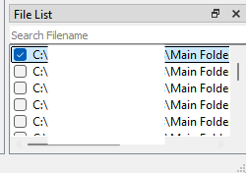

*Figure 3.4.2 Checkmark at Image with Saved JSON file in File List in LabelMe*

**Note:** Please make sure that the file name is unedited and is a JSON file.

If there is more than 1 rectangle, only the first rectangle created will be read by the program.

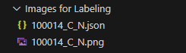 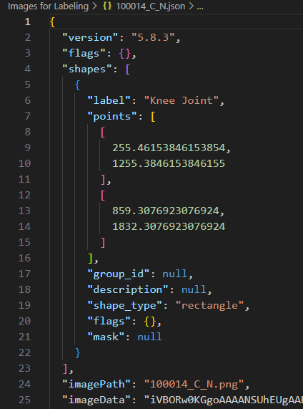

*Figure 3.4.3 Sample Folder Structure after Saving Figure 3.4.4 Sample JSON File Contents*

# Step 4: Creating YOLO Required Dataset

These steps convert the current images and labels into a dataset required for training a YOLO model.

## 4.1 Splitting Training and Inference Images

The training and inference images with their JSON files should be split into the folders “Training Folder” and “Inference Folder” now. For this demonstration, there are 30 training images and 10 inference images.

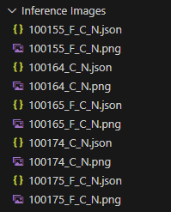 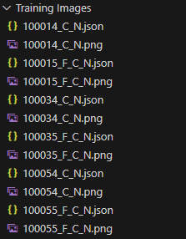

*Figure 4.1.1 Sample “Inference Images” Structure Figure 4.1.2 Sample “Training Images” Structure*

## 4.2 Converting LabelMe JSON file to YOLO TXT file

The format of labels required for YOLO training is different from labels generated from LabelMe. This step converts LabelMe JSON files to YOLO TXT files with converted information.

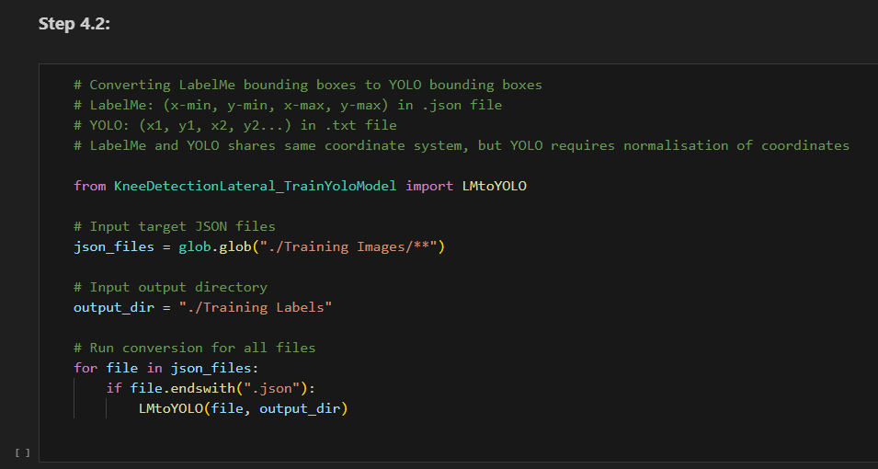

*Figure 4.2.1 “Step 4.2” Section*

### Input: JSON Files, Output Directory:

json_files: The target JSON files. Update the string to retrieve the correct target JSON files.

output_dir: The target folder to save output TXT files. Update the string to change the target folder.

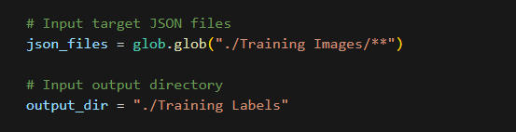

*Figure 4.2.2 “Step 4.2” Sample Input Parameters*

### Output: TXT Files, Debug Information:

The text files should be stored in the targeted folder, with the same file name as the original JSON file.

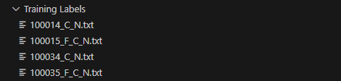

*Figure 4.2.3 “Step 4.2” Sample Output Structure*



*Figure 4.2.4 “Step 4.2” Sample Output TXT File*

Debug Information:

x minimum, y minimum, x maximum, y maximum, width of image, height of image

normal x minimum, normal y minimum, normal x maximum, normal y maximum

JSON path

TXT path

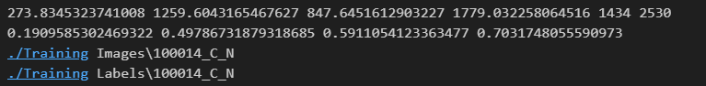

*Figure 4.2.5 “Step 4.2” Sample Printed Output*

## 4.3 Creating YOLO Dataset

This step collects the images and text files and puts them in a format recognisable by the YOLO model trainer. This step also splits the images into training images and testing images.

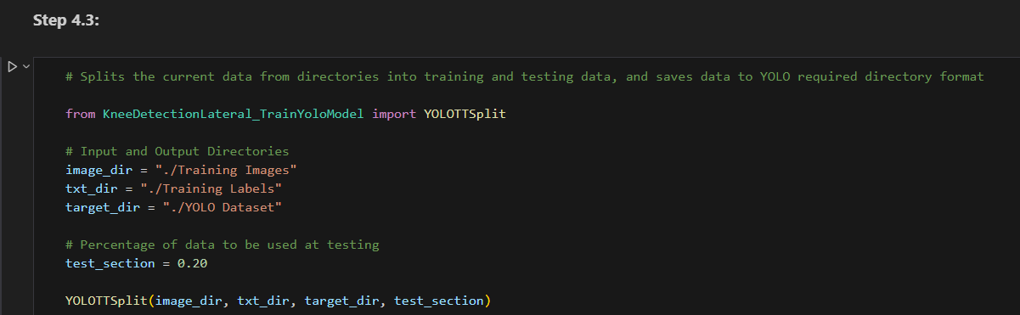

*Figure 4.3.1 “Step 4.3” Section*

### Input: Image Directory, Text Files Directory, Target Directory

image_dir: The target folder with the PNG files. Update the string to change the target folder.

target_dir: The target folder with the TXT files containing the bounding box label. Update the string to change the target folder.

target_dir: The target folder to save the dataset. Update the string to change the target folder.

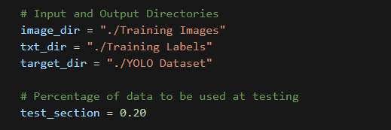

*Figure 4.3.2 “Step 4.3” Sample Input Parameters*

### Output: YOLO Dataset

The YOLO dataset in the required format will be copied into the target folder.

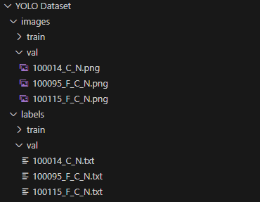

*Figure 4.3.3 “Step 4.3” Sample Output Structure*

## 4.4 Creating YOLO YAML file

This step creates or updates a YAML file, which is required to direct the model trainer to the dataset.

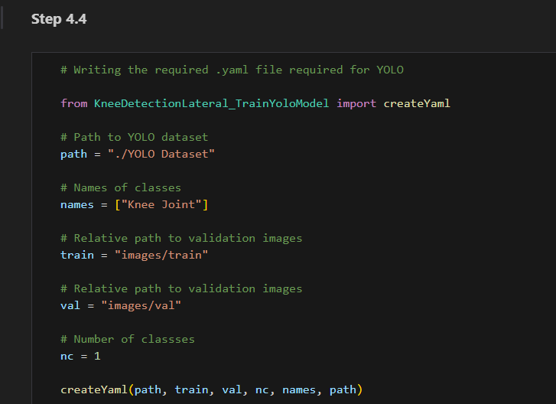

*Figure 4.4.1 “Step 4.4” Section*

### Input: YAML Required Information

path: The target folder with the YOLO Dataset. Update the string to change the target folder.

names: The name of the bounding box. Update the string to change the name.

train, val, nc: Relative path to training and validation images, and number of classes. Should remain unchanged if Steps 4.1 and 4.2 were used to create the dataset.

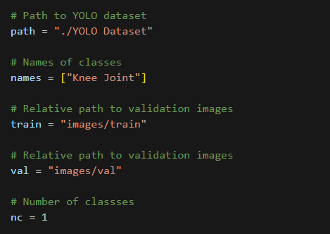

*Figure 4.4.2 “Step 4.4” Sample Input Parameters*

### Output: YAML File

The YAML File will be updated or added to the folder with the YOLO Dataset.

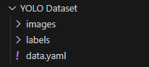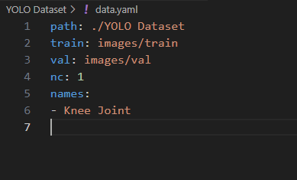

*Figure 4.4.3 “Step 4.4” Sample Output Structure & YAML File*

# Step 5: Fine-tuning YOLO Model

These steps fine-tune a YOLO11 nano segmentation model, along with a guide to understand the output metrics of the training.

## 5.1 Fine-Tuning New Model

This step fine-tunes a pre-trained YOLO11 nano segmentation model with the dataset.

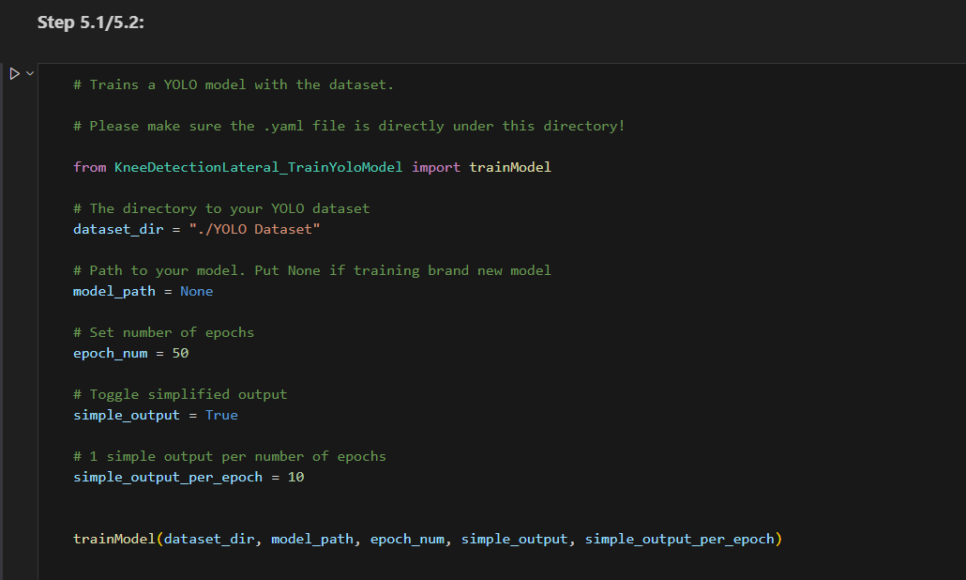

*Figure 5.1.1 “Step 5.1/5.2” Section*

### Input: Dataset Directory, Training Parameters

dataset_dir: The target folder with the YOLO Dataset. Update the string to change the target folder.

model_path: **None**. This option is used for training a new model.

epoch_num: Number of epochs used in training.

simple_output: If True, activates a custom-made output system with a text file.

simple_output_per_epoch: Number of epochs before generating an output in the custom output system.

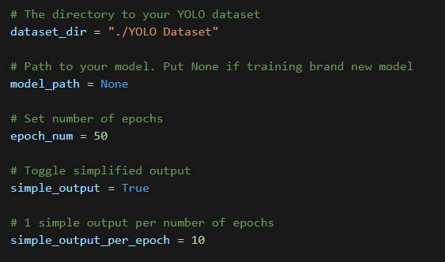

*Figure 5.1.2 “Step 5.1/5.2” Sample Input Parameters*

### Output: Completed Model Run Folder

A new folder “runs\segment\train” should appear with data shown in Figure 5.1.3 in the main folder.

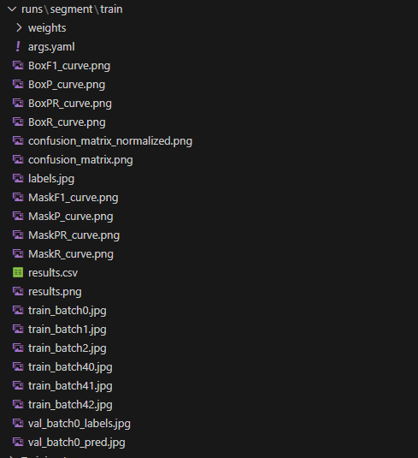

*Figure 5.1.3 “Step 5.1/5.2” Sample Training Output*

For the details of this output, please refer to Step 5.3.

### Simple Output System:

A new text file “custom_output.txt” will be added to the YOLO dataset folder.

For every epoch, the following information will be collected and combined into a single JSON file.

* Best Fitness
* Box loss and the lowest box loss achieved
* Segmentation (Seg) loss and the lowest segmentation loss achieved
* Classification (Cls) loss and the lowest classification loss achieved
* Distributed focal loss (Dfl) and the lowest distributed focal loss achieved
* Box precision, recall, mAP50 and mAP50–95 and their highest achieved value
* Mask precision, recall, mAP50 and mAP50–95 and their highest achieved value

For the details of these metrics, please refer to Step 5.3.

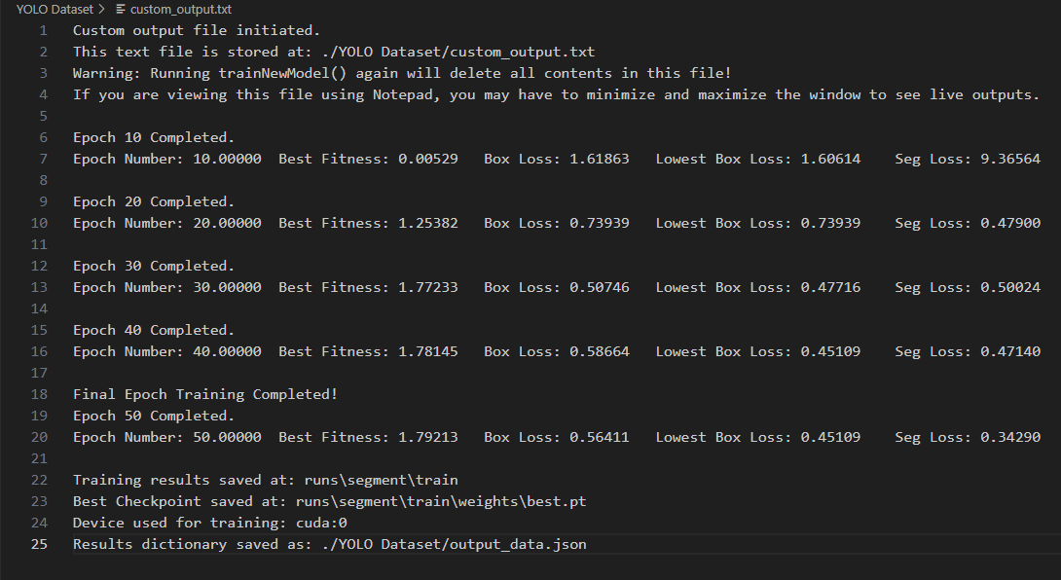

*Figure 5.1.4 Sample Simple Output System Output (Contents of custom_output.txt)*

As seen in Figure 5.1.4, the paths for storing:

* This text file
* Training results
* Best model checkpoint (model at epoch with best performance)
* Epoch data (output_data.json)

And the device used for training will also be printed.

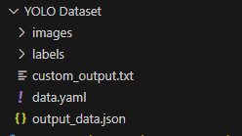

*Figure 5.1.5 Sample YOLO Dataset Folder Structure after Output*

## 5.2 Re-training Trained Model

To train a saved model, input the path of the target model in the model_path parameter in Step 5.1.

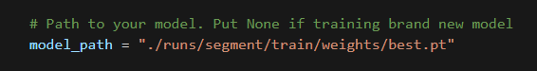

*Figure 5.2.1 “Step 5.1/5.2” Sample model_path Input to Train Saved Model*

The input parameters, functionality, and outputs are identical to those in Step 5.1. Please refer to Step 5.1.

## 5.3 Interpreting Training Results

| Metric Type: | Calculated based on: |
| --- | --- |
| Box- | The rectangular bounding box containing the labelled shape. |
| Mask- | Directly compare the labelled shape between prediction and ground truth. |
| Train- | Metrics gathered with training images. |
| Val- | Metrics gathered with validation images. |

*Figure 5.3.1 Table of Types of Metrics*

| Loss Metrics: | Calculation: | Significance: |
| --- | --- | --- |
| Box Loss (box_loss) | Complete Intersection over Union (IoU) | Addresses correctly indicating the bounding box position |
| Segmentation Loss (seg_loss) | Combining Binary Cross Entropy (BCE) and Dice Coefficient | Addresses the similarity between the shape of the prediction and the ground truth |
| Classification Loss (cls_loss) | Binary Cross Entropy (BCE) | Addresses correctly classifying detected objects |
| Distributed Focal Loss (dfl_loss) | Unknown | Addresses discerning background and target object |

*Figure 5.3.2 Table of Loss Metrics*

| Performance Metrics: | Definition: | Significance: |
| --- | --- | --- |
| Precision | Accuracy of detected objects. | Indicates the number of correct predictions. |
| Recall | Ability to detect all objects. | Indicates cases of false negatives. |
| mAP50 | Mean Average Precision (mAP) with an IoU threshold of 0.5. | The accuracy of predicting easier objects. |
| mAP50-95 | Average value between mAP50, mAP55, until mAP95. | A stricter value shows the accuracy of predicting more difficult objects. |

*Figure 5.3.2 Table of Performance Metrics*

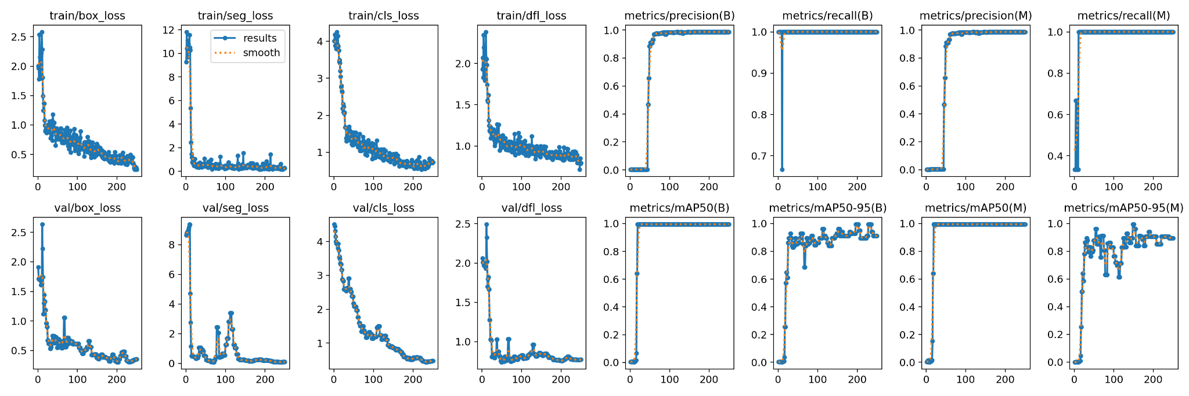

*Figure 5.3.4 Sample “results.png” Containing Curves of Metrics*

Curves:

| Curves: | Definition: |
| --- | --- |
| F1-Confidence | Harmonic mean of precision and recall at different confidence levels. |
| Precision-Confidence | Values of precision for different confidence values. |
| Recall-Confidence | Values of recall for different confidence values. |
| Precision-Recall | Relationship between precision and recall. |

*Figure 5.3.5 Table of Types of Curves*

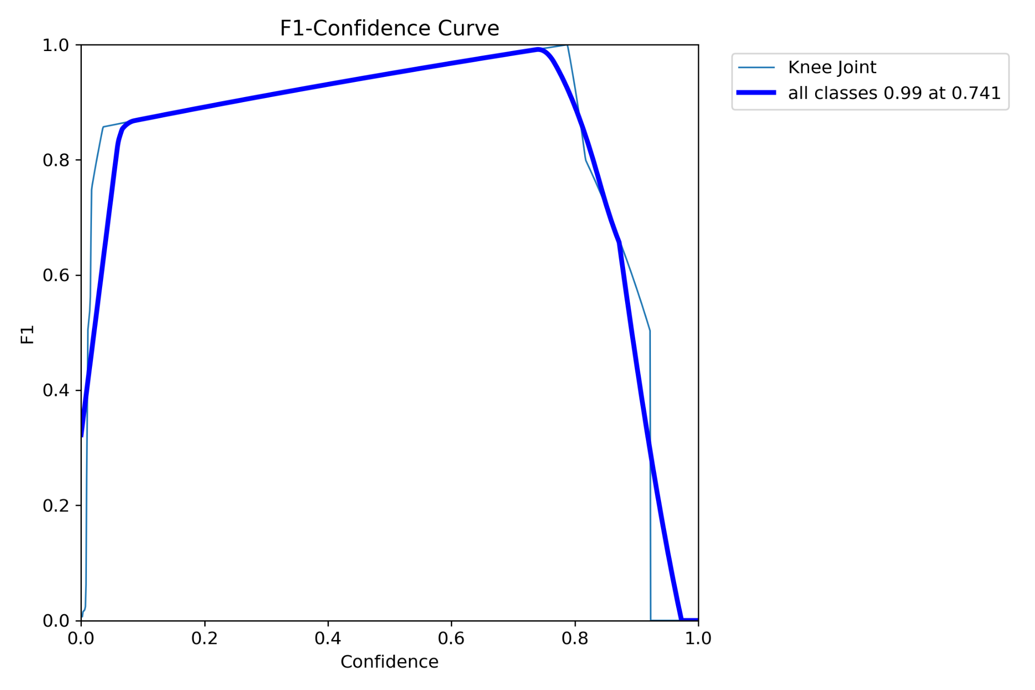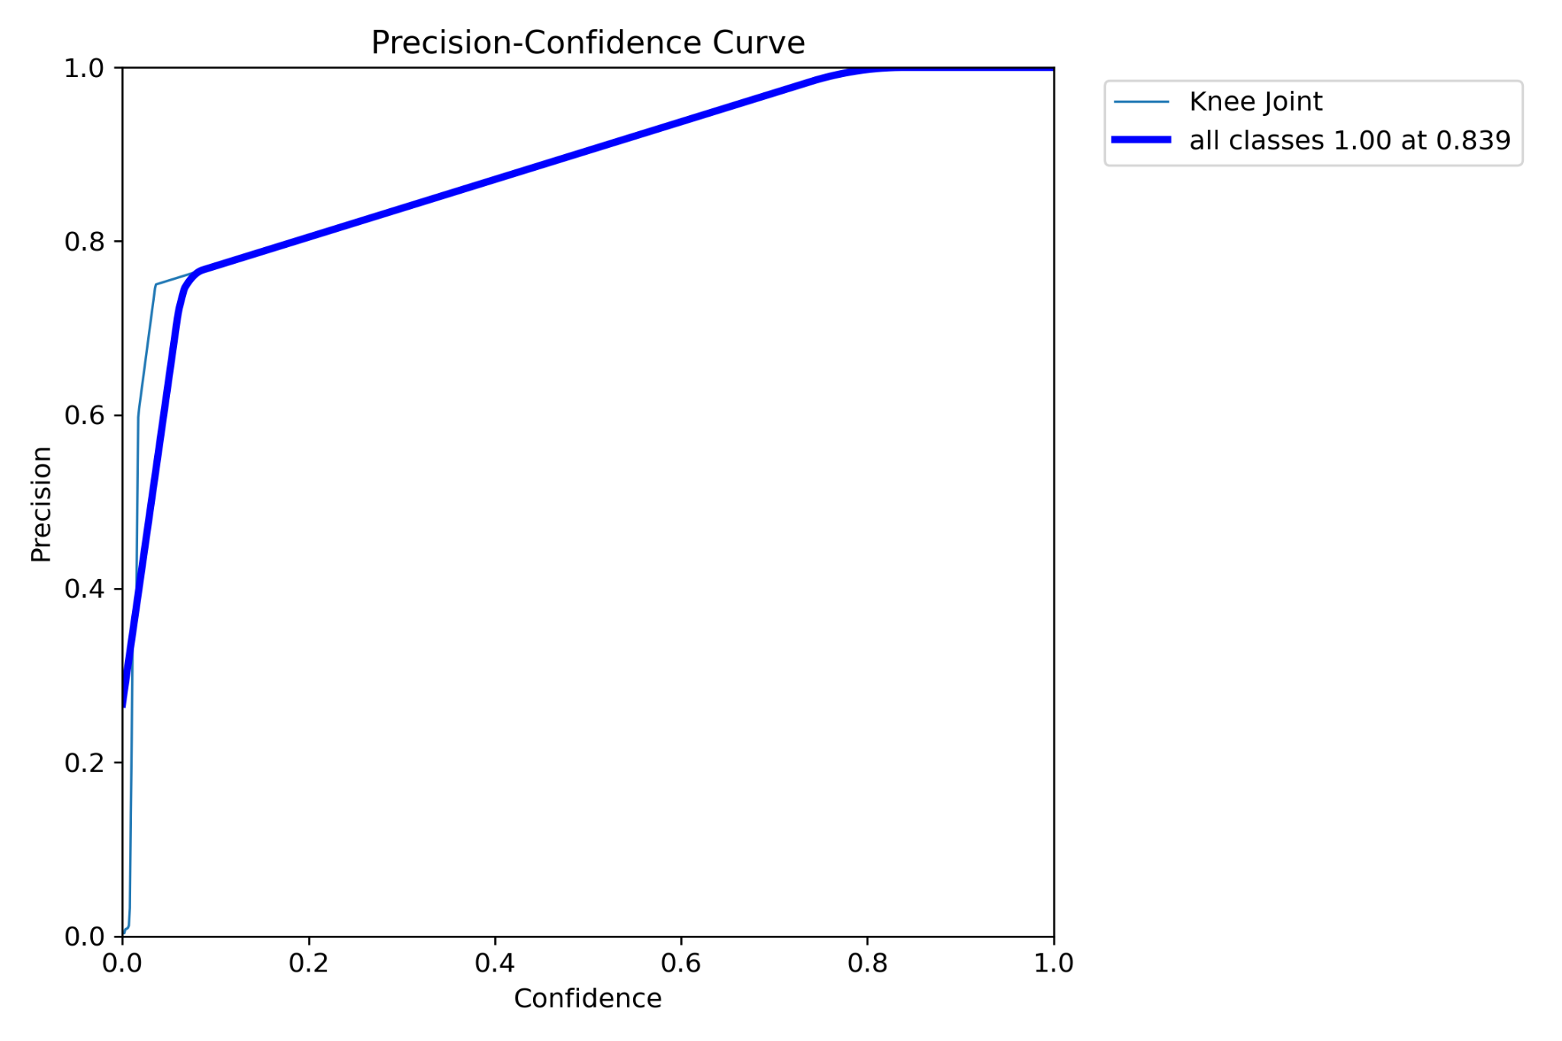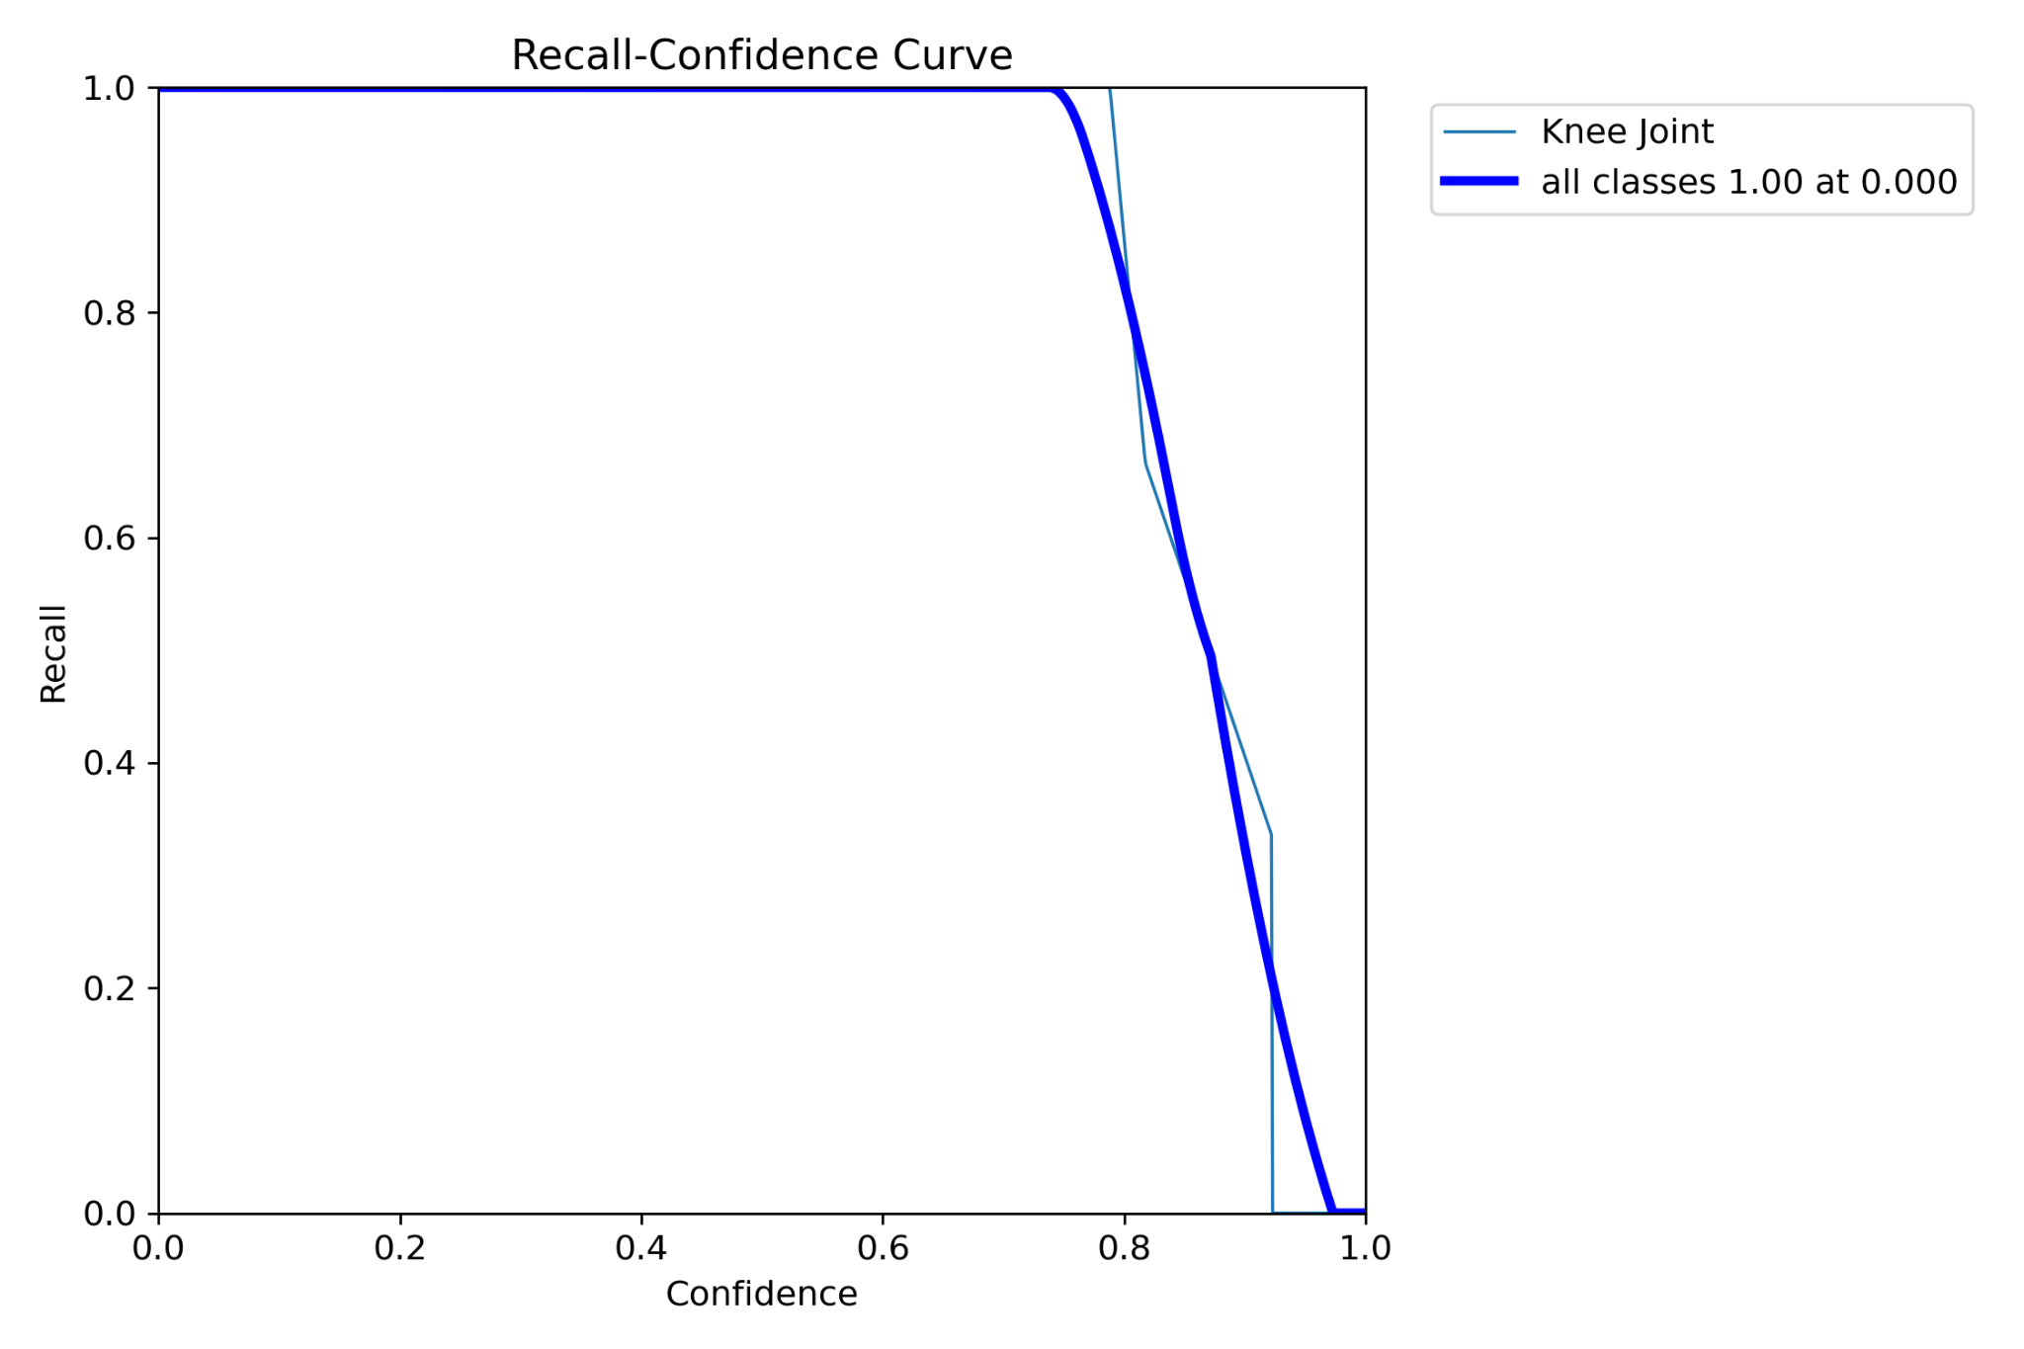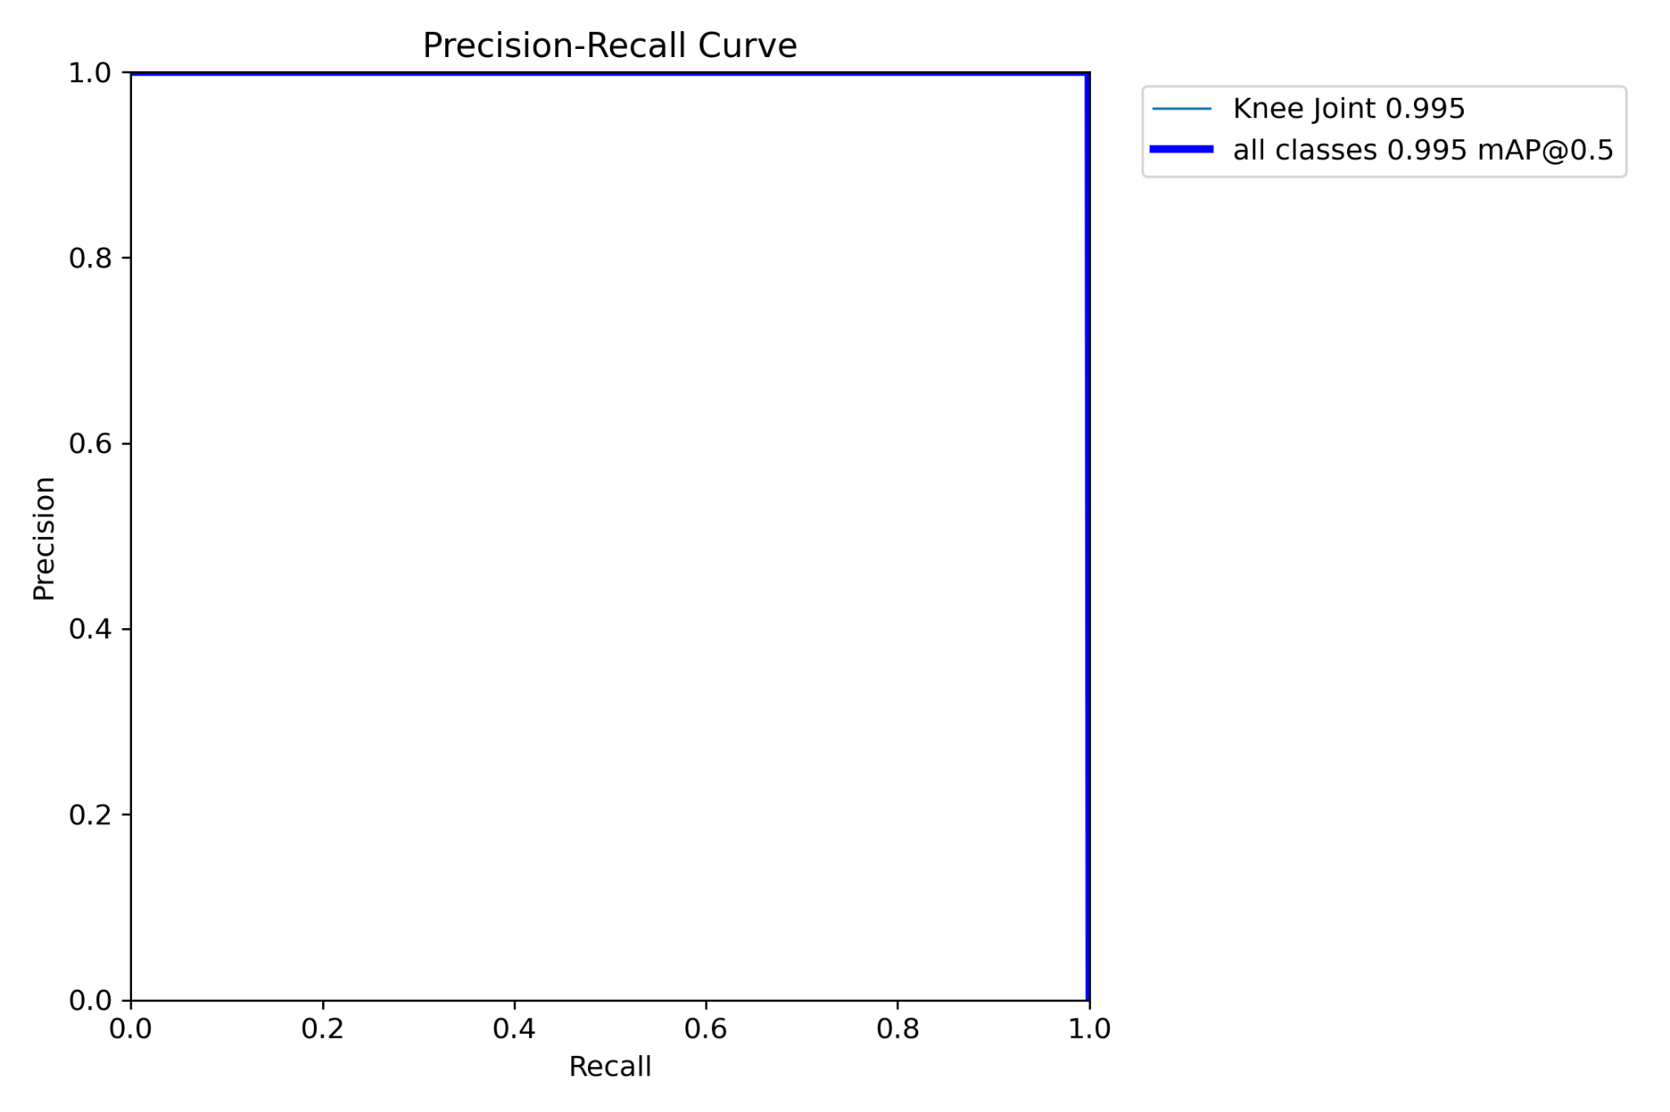

*Figure 5.3.6 Sample* F1-Confidence, Precision-Confidence, Recall-Confidence, Precision-Recall Graphs

Predictions:

train_batch.jpg: Images with the ground truth labelled. These images are used for training the model, and may appear jumbled or irregular due to automatic image augmentation by the YOLO trainer.

Only the first and last 3 train_batch images will be saved.

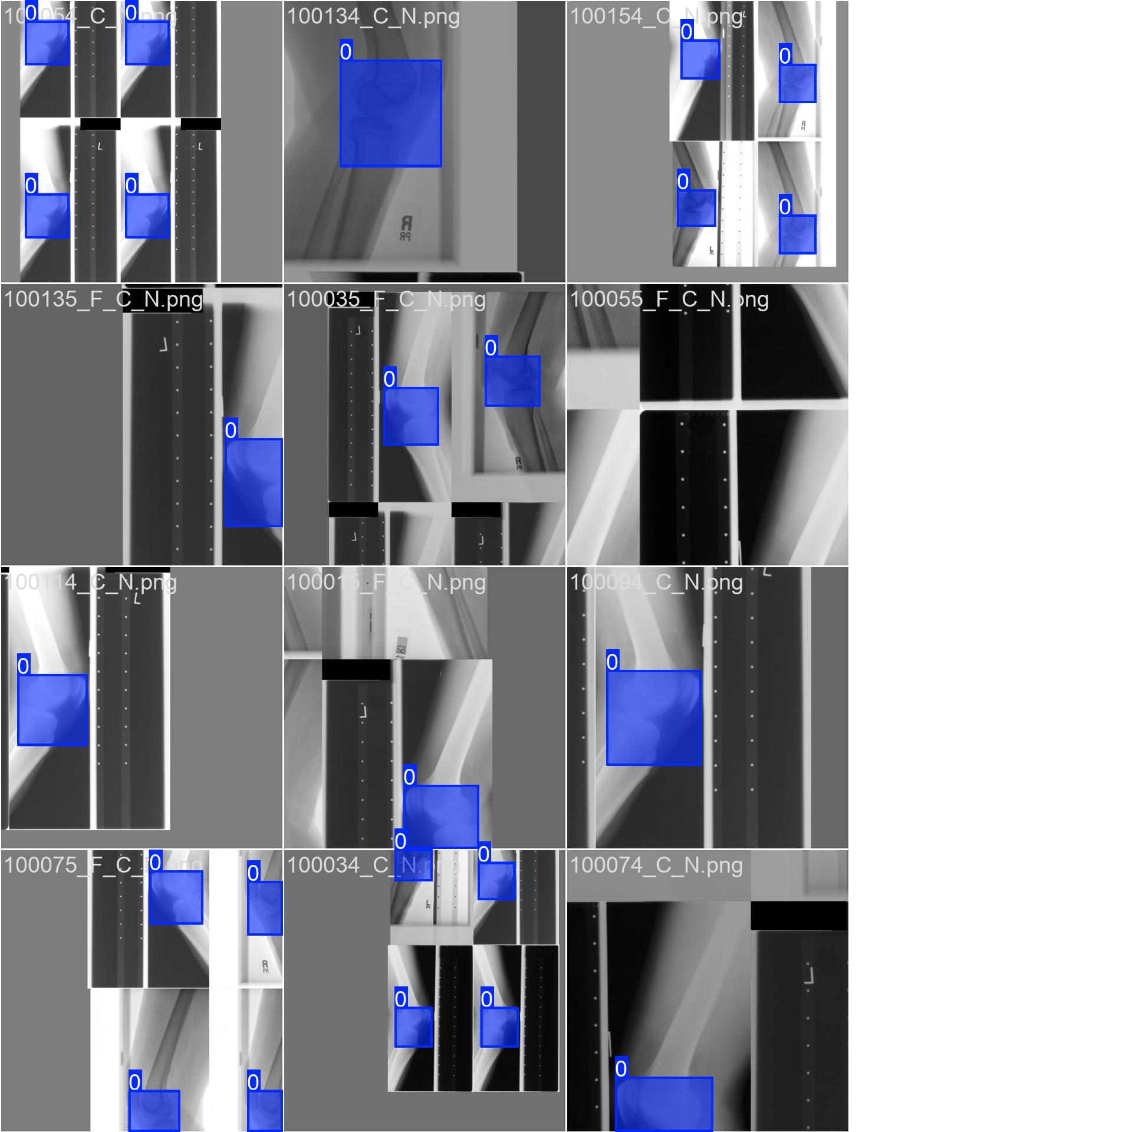

*Figure 5.3.7 Sample “train_batch0.jpg”*

val_batch0_pred.jpg: Images with prediction made with the model. The class label and confidence will also be labelled.

val_batch0_labels.jpg: Images with the ground truth labelled. Compare with val_batch0_pred.jpg to evaluate the model’s performance.

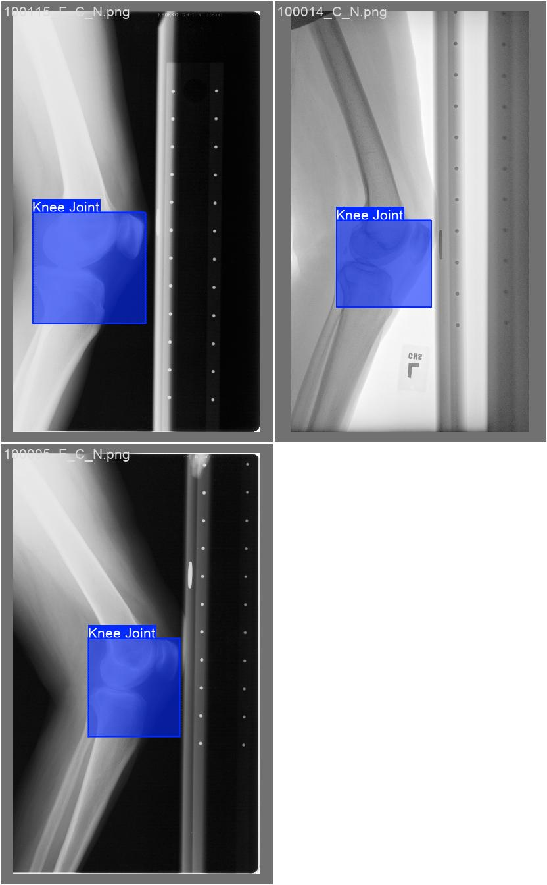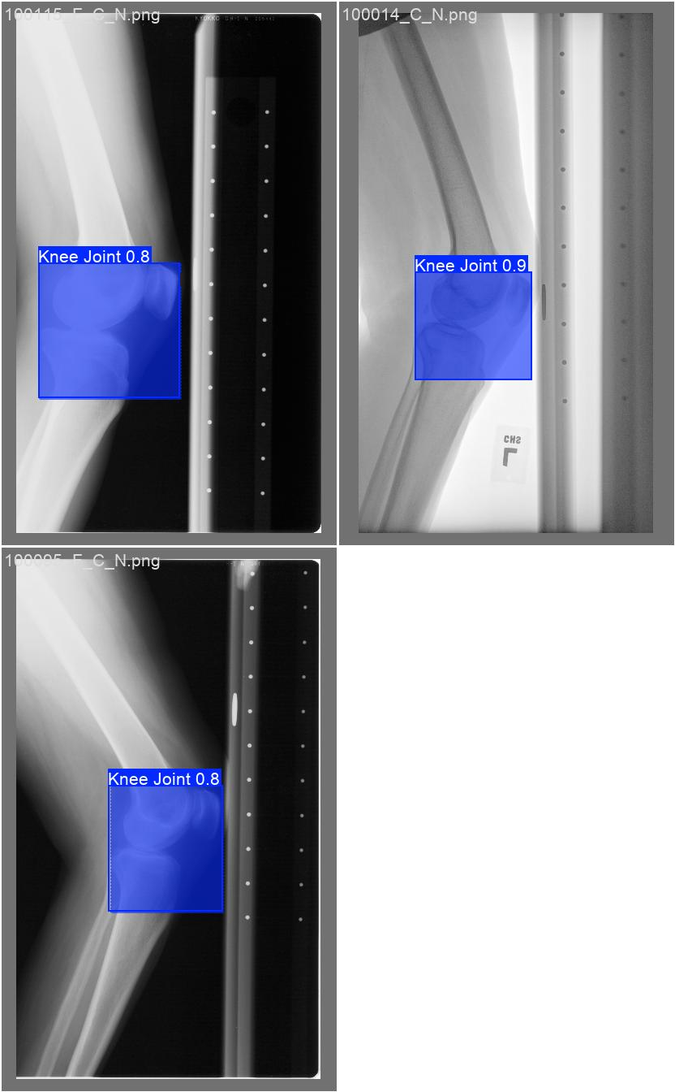

*Figure 5.3.8 Sample “*val_batch0_labels.jpg*” (left) and “*val_batch0_pred.jpg*” (right)*

If the graphs in results.png are not clear enough, or the shape is obstructed by random high outliers:

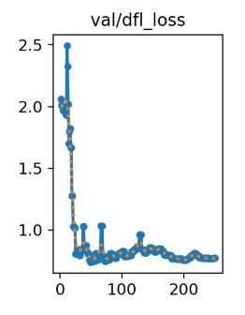

*Figure 5.3.9 Sample “val/dfl_loss” graph with high outlier*

Consider running extraResultPlots() in Step 5.3 to generate graphs at a larger scale.

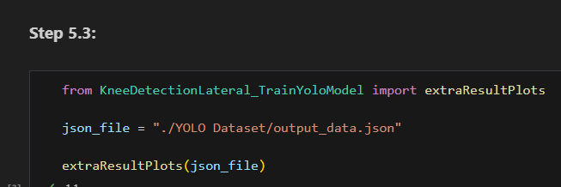

*Figure 5.3.10 “Step 5.3” Section*

### Input: JSON File

Input the path to the JSON file generated by Step 5.1 or 5.2.

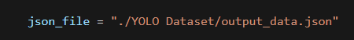

*Figure 5.3.11 “Step 5.3” Sample Input Parameter*

### Output: 5x5 Matplotlib Plot

A Matplotlib plot should be outputted with 25 graphs in a 5x5 format.

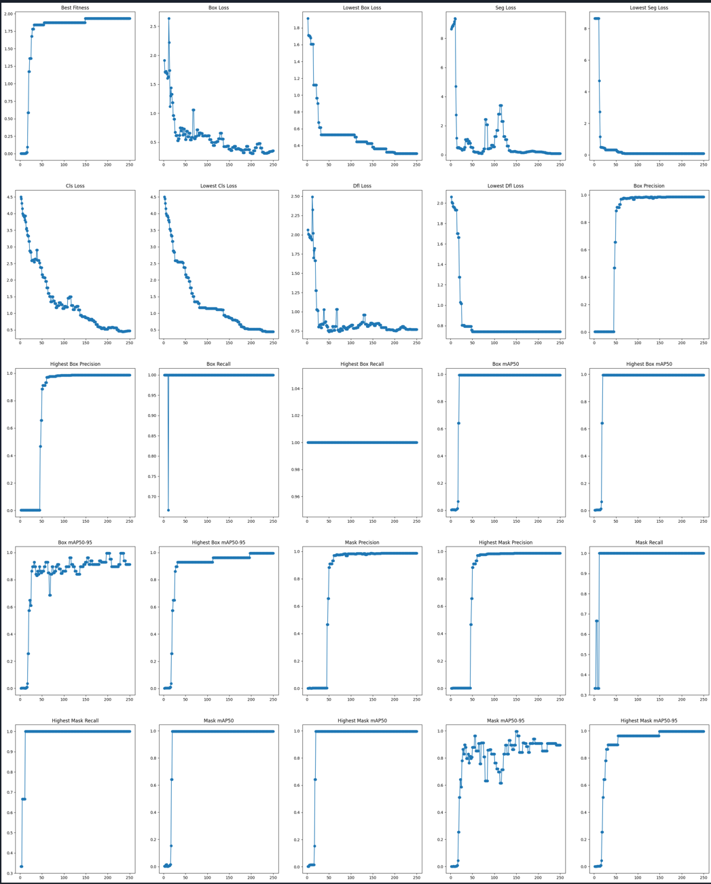

*Figure 5.3.12 “Step 5.3” Sample Output Plot*

# Step 6: Inference with Tuned Model

These steps run an inference test with completely new images, testing the performance and capabilities of the trained model.

## 6.1 Dataset Preparation

This step converts inference labels in the same way as the training labels.

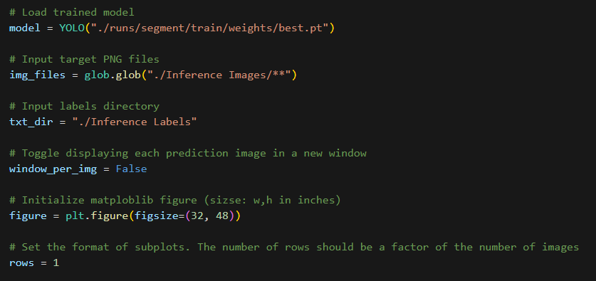

*Figure 6.1.1 “Step 6.1” Section*

### Input: JSON Files, Output Directory:

json_files: The target JSON files. Update the string to retrieve the correct target JSON files.

output_dir: The target folder to save output TXT files. Update the string to change the target folder.

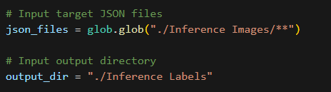

*Figure 6.1.2 “Step 6.1” Sample Input Parameters*

### 

### Output: TXT Files, Debug Information:

The text files should be stored in the targeted folder, with the same file name as the original JSON file.

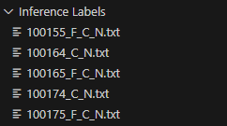

*Figure 6.1.3 “Step 6.1” Sample Output Structure*

For the text file content and debug information format, please refer to Figures 4.2.4 & 4.2.5.

## 6.2 Running Inference

This step contains the inference program. Inference images are passed through the model, and statistics are returned.

### Input: Loaded model, Input Parameters, Plotting parameters

model: A loaded YOLO model. Update the string to the path to your model.

img_files: The target PNG files. Update the string to retrieve the correct target PNG files.

txt_dir: The directory to your TXT files. Update the string to the correct directory.

window_per_img: Update to True for displaying **each** image in a new window.

(Recommended to be False if a large number of inference images to avoid large clutter)

figure: Update figsize to change the size of the plot. Increase if more images.

rows: Number of rows in the plot. This number should be a factor of the number of images.

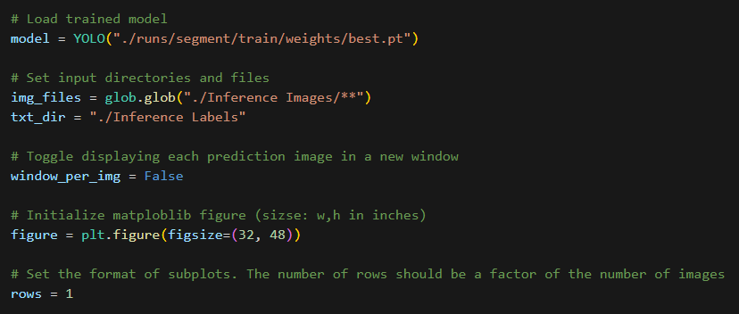

*Figure 6.2.1 “Step 6.2” Sample Input Parameters*

### Output: Matplotlib Plot, Printed Statistics

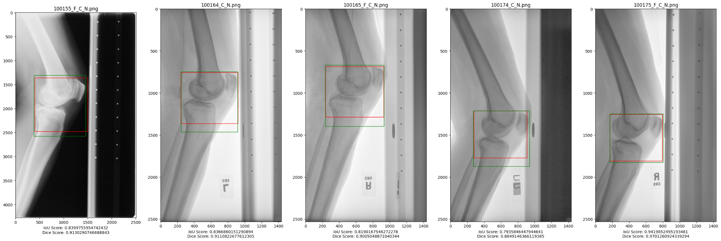

*Figure 6.2.2 “Step 6.2” Sample Output Plot*

In Figure 6.2.2, the green rectangle represents the ground truth, while the red rectangle represents the model’s prediction. For each image, the IoU value and the dice coefficient are also given.

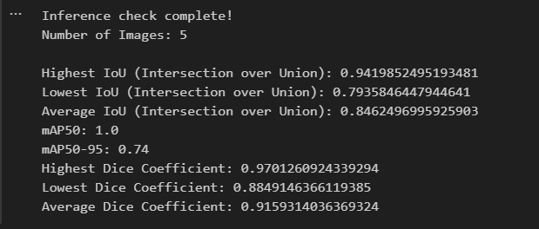

*Figure 6.2.3 “Step 6.2” Sample Printed Output*

Additional statistics will be printed for recording, as shown in Figure 6.2.3.

# 

# Step 7: Cropping Images with Tuned Model

If inference yielded successful or expected results, the model can be used to crop images to their region of interest. These steps crop the image and process the image for the final output.

## 7.1 Cropping Rectangular Image

This step converts inference labels in the same way as the training labels.

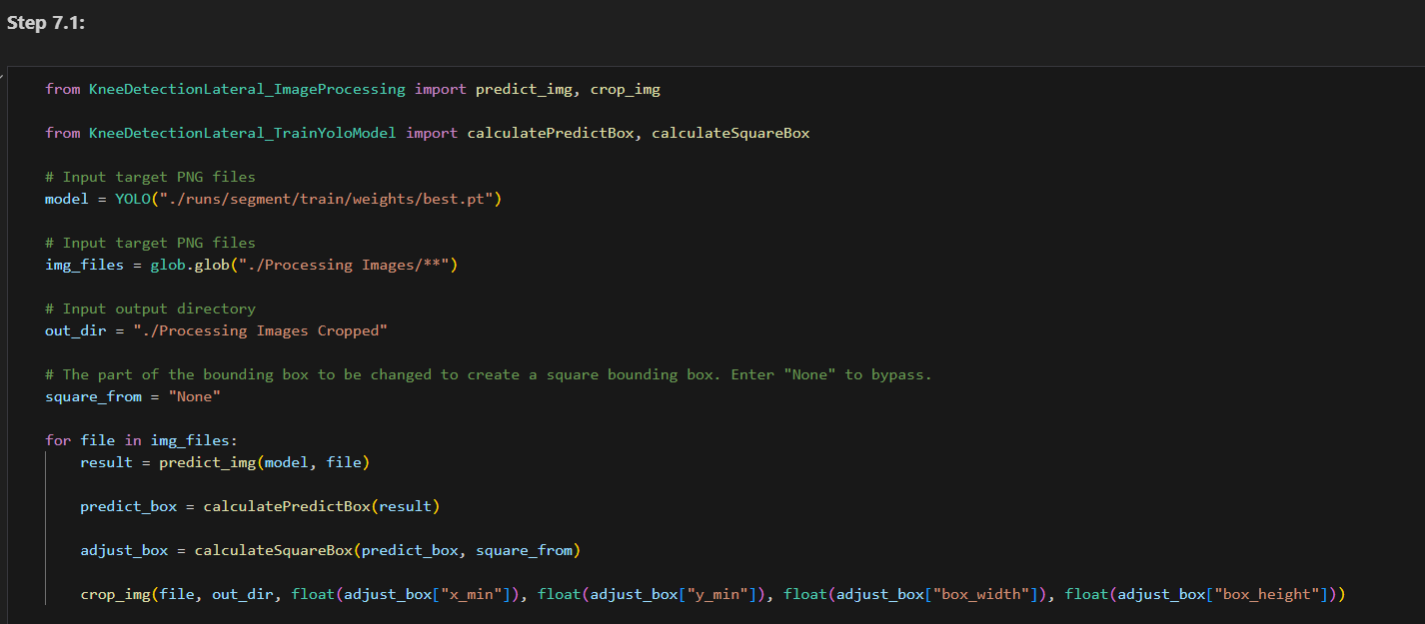

*Figure 7.1.1 “Step 7.1” Section*

### Input: Loaded Model, PNG Files, Output Directory, Customisation

model: A loaded YOLO model. Update the string to the path to your model.

img_files: The target PNG files. Update the string to retrieve the correct target PNG files.

out_dir: The target folder to save the output PNG files. Update the string to change the target folder.

square_from: For cropping the entire bounding box, input “None”.

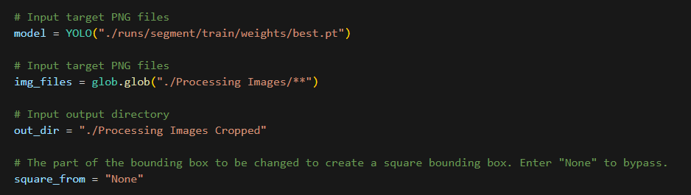

*Figure 7.1.2 “Step 7.1” Sample Input Parameters*

### Output: Cropped PNG Files:

The image files should be stored in the targeted folder, with the same file name as the original PNG file.

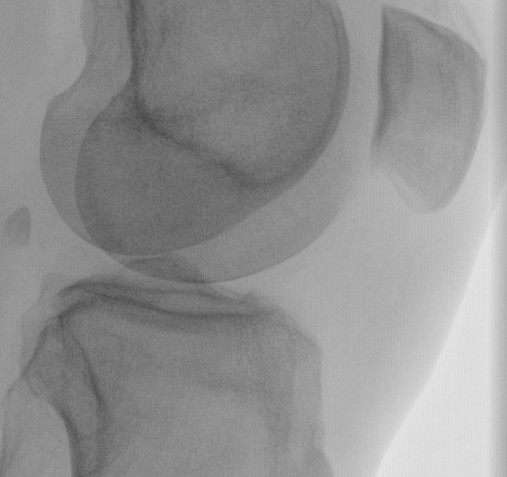

*Figure 7.1.3 “Step 7.1” Sample Output Image*

## 7.2 Cropping Square Image

In Step 7.1, this step was omitted. For cropping a square image, the calculateSquareBox() function can be used to calculate a square bounding box and update the box coordinates for the cropping function.

To use this function, change the parameter square_from from “None” to one of the following options:

* “Horizontal”
* “Vertical”
* “Left”
* “Right”
* “Top”
* “Bottom”

### 

*Figure 7.2.1 “Step 7.1” Sample square_from Value*

Each option will either crop or extend the bounding box differently, as shown in Figures 7.2.2 and 7.2.3.

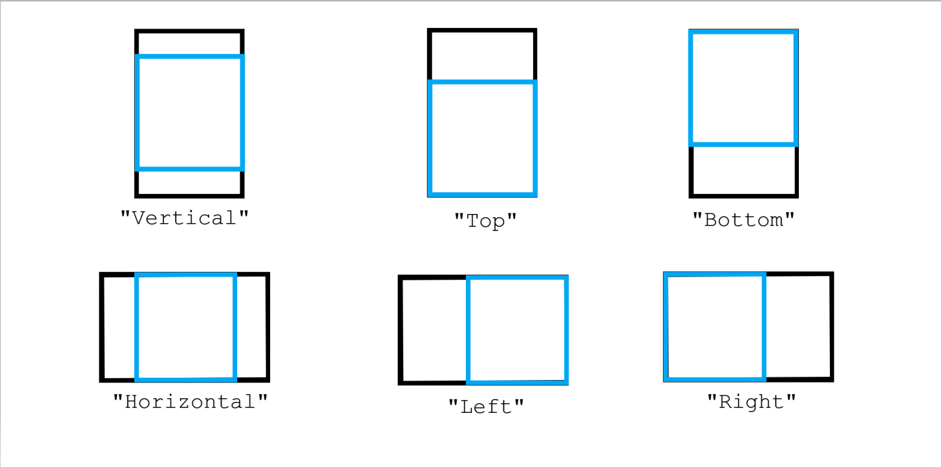  
*Figure 7.2.2 square_from Options Cropping Diagram (Blue: Cropped, Black: Original)*

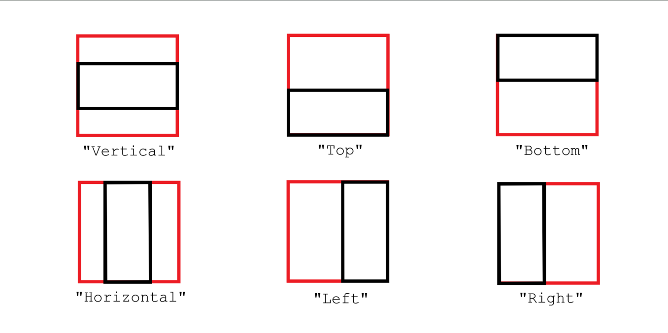

*Figure 7.2.3 square_from Options Extending Diagram (Red: Extended, Black: Original)*

## 

For lateral knee images, this is a sample of the rectangular bounding box.

## 

*Figure 7.2.4 Sample Rectangular Cropped Lateral Knee Image*

From Figure 7.2.4, the patella defines the top and the right edge of the image, while the tibia defines the left edge of the image. The bottom edge lacks defining features, which can cause the model to misjudge the bottom edge position often.

Hence, this function should be run with the “Bottom” option to adjust the bottom edge position until the bounding box is a square.

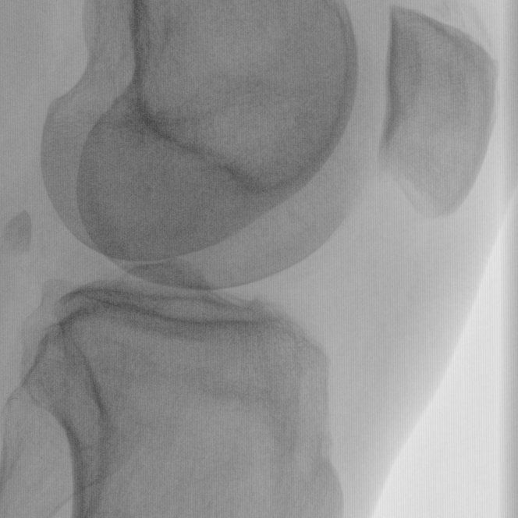

*Figure 7.2.5 Sample Square Cropped Lateral Knee Image using “Bottom” Option*

## 

## 7.3 Post-processing

This step includes normalisation and applying CLAHE normalisation to create a clearer output image.

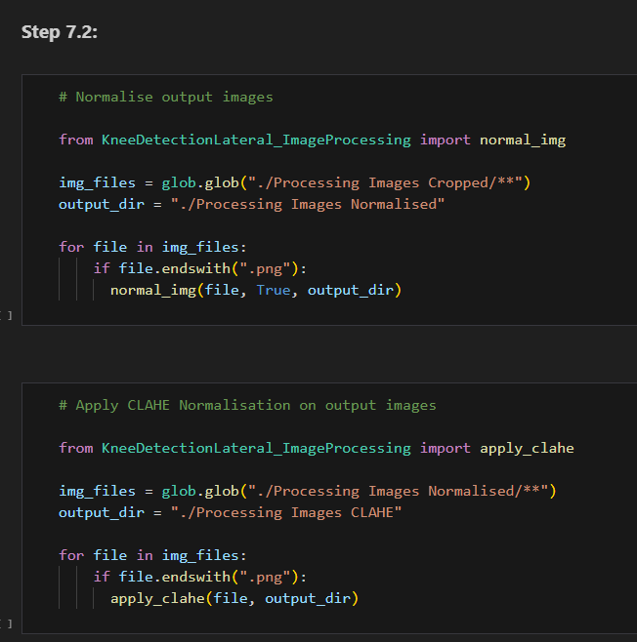

*Figure 7.3.1 “Step 7.3” Section*

### Input: PNG Files

For both sections,

img_files: The target PNG files. Update the string to retrieve the correct target PNG files.

out_dir: The target folder to save the output PNG files. Update the string to change the target folder.

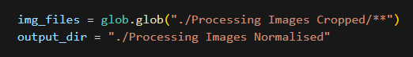

*Figure 7.3.2 “Step 7.3” Sample normal_img() Input Parameters*

### 

### Output: (CLAHE) Normalised PNG File

The images should be stored in the targeted folder, with “_N.png” added as a suffix.

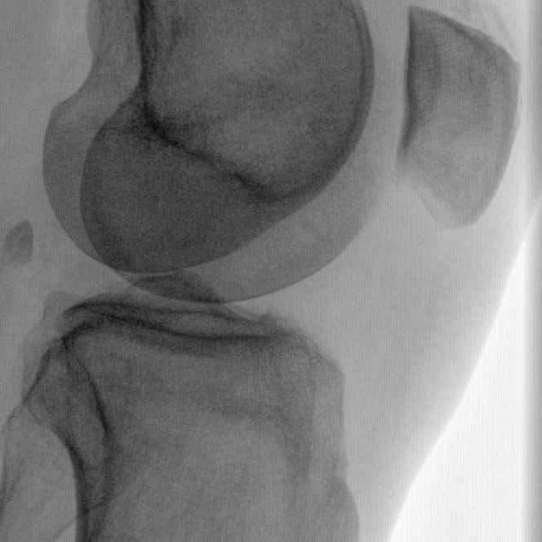

*Figure 7.3.3 “Step 7.3” Sample normal_img() Output Image*

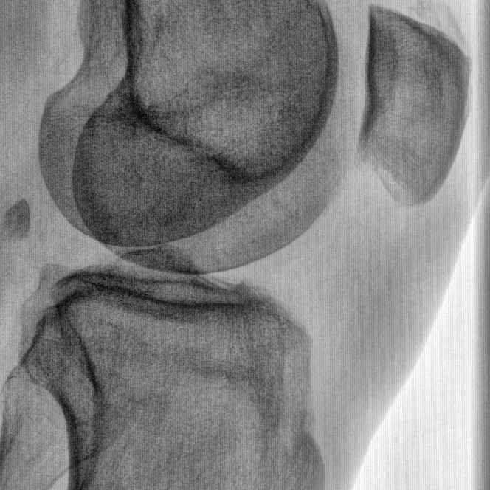

*Figure 7.3.4 “Step 7.3” Sample apply_clahe() Output Image*

# 

# Conclusion

The program was able to train a YOLO segmentation model that was able to identify and detect the required region of interest. The program was then able to crop the region of interest, producing the required final images, as shown in Figure 7.3.4.

# Acknowledgement:

@software{yolov8_ultralytics,

author = {Glenn Jocher and Ayush Chaurasia and Jing Qiu},

title = {Ultralytics YOLOv8},

version = {8.0.0},

year = {2023},

url = {https://github.com/ultralytics/ultralytics},

orcid = {0000-0001-5950-6979, 0000-0002-7603-6750, 0000-0003-3783-7069},

license = {AGPL-3.0}

}